# COVER

Image Processing and Recognition

Mini Project

Image Processing Tkinter User Manual Application

Group Members:

Abdurrahman Khairi 001202300163

Filbert Sembiring Meliala 001202300159

Jason Anthony Wibowo 001202300216

PRESIDENT UNIVERSITY

2025

# TABLE OF CONTENT

COVER i

TABLE OF CONTENT ii

CHAPTER I INTRODUCTION 1

1.1 Overview of the Project 1

1.2 Goals and Objectives 1

5.4.1 Building Practical Skills: 1

5.4.2 Enhancing Problem-Solving Abilities: 2

5.4.3 Promoting Collaboration: 2

5.4.4 Developing a Comprehensive Application: 2

1.3 Project Scope 2

CHAPTER II SYSTEM REQUIREMENTS 3

2.1 Hardware Requirements: 3

2.1.1 Processor: 3

2.1.2 RAM: 3

2.1.3 GPU: 3

2.1.4 Storage: 3

2.1.5 Display: 3

2.2 Software Requirements: 3

2.2.1 Operating System Compatibility: 3

2.2.2 Required Libraries and Software: 3

CHAPTER III INSTALLATION INSTRUCTIONS 5

3.1 Step-by-Step Installation Process: 5

3.1.1 Install Python: 5

3.1.2 Install Required Libraries: 5

3.1.3 Download the Image Processing Application: 5

3.1.4 Verify Installation: 6

3.2 Initial Setup: 6

CHAPTER IV USER INTERFACE OVERVIEW 8

4.1 System Interface 8

4.1.1 Layout Application 8

4.1.2 Layout 9

4.1.3 Layout Tools 10

4.1.4 Layout Chapter I - Basic Image Operation 11

4.1.5 Layout Chapter II - Mathematical Operations on Image 12

4.1.6 Layout Chapter III - Transforms and Filtering in Image Processing 12

4.1.7 Layout Chapter IV - Image Enhancement 12

4.1.8 Layout Chapter V - Image Compression 12

4.1.9 Layout Chapter VI - Image Segmentation Using Thresholding and Clustering 13

4.1.10 Layout Chapter VII - Binary Image Processing 13

4.1.11 Layout Chapter VIII - Image Restoration 13

4.1.12 Layout Chapter IX - Image Matching 13

4.2 Buttons 14

4.2.1 Load Image 14

4.2.2 Reset Image 14

4.2.3 Save Image 14

4.2.4 Button Chapter I - Basic Image Operation - Greyscale Conversion 14

4.2.5 Button Chapter I - Basic Image Operation – Negative Transformation 14

4.2.6 Button Chapter I - Basic Image Operation – Color Manipulation 15

4.2.7 Button Chapter I - Basic Image Operation – Flip Operations 15

4.2.8 Button Chapter I - Basic Image Operation – Translation 15

4.2.9 Button Chapter I - Basic Image Operation – Scaling 15

4.2.10 Button Chapter I - Basic Image Operation – Rotation 15

4.2.11 Button Chapter I - Basic Image Operation – Cropping 15

4.2.12 Button Chapter I - Basic Image Operation – Image Blending 15

4.2.13 Button Chapter I - Basic Image Operation – Brightness Adjustment 16

4.2.14 Button Chapter I - Basic Image Operation – Contrast Adjustment 16

4.2.15 Button Chapter I - Basic Image Operation – Color Filtering 16

4.2.16 Button Chapter I - Basic Image Operation – Border and Padding 16

4.2.17 Button Chapter I - Basic Image Operation – Image Overlay 16

4.2.18 Button Chapter II - Mathematical Operations on Image – Pixel-wise Operations 16

4.2.19 Button Chapter II - Mathematical Operations on Image – Bitwise Operations 17

4.2.20 Button Chapter III - Transforms and Filtering in Image Processing – Fourier Transform 17

4.2.21 Button Chapter III - Transforms and Filtering in Image Processing – Spatial Filters 17

4.2.22 Button Chapter III - Transforms and Filtering in Image Processing – Edge Detection 17

4.2.23 Button Chapter IV - Image Enhancement – Histogram Equalization 17

4.2.24 Button Chapter IV - Image Enhancement – Contrast Stretching 17

4.2.25 Button Chapter IV - Image Enhancement – Gamma Correction 18

4.2.26 Button Chapter V - Image Compression – Lossless Compression 18

4.2.27 Button Chapter V - Image Compression – Lossy Compression 18

4.2.28 Button Chapter VI - Image Segmentation Using Thresholding and Clustering - Thresholding 18

4.2.29 Button Chapter VI - Image Segmentation Using Thresholding and Clustering – K-Means Clustering 18

4.2.30 Button Chapter VII - Binary Image Processing- Morphological Operations 18

4.2.31 Button Chapter VII - Binary Image Processing – Boundary Extraction 19

4.2.32 Button Chapter VII - Binary Image Processing - Skeletonization 19

4.2.33 Button Chapter VIII - Image Restoration – Noise Reduction 19

4.2.34 Button Chapter VIII - Image Restoration - Inpainting 19

4.2.35 Button Chapter IX - Image Matching - FeatureDetection 19

4.2.36 Button Chapter IX - Image Matching – Template Matching 19

4.3 Navigation In the System 20

4.4 Features and Functionality 20

CHAPTER V HOW TO USE THE SYSTEM 22

5.1 Chapter I - Basic Image Operation - Greyscale Conversion 22

5.2 Chapter I - Basic Image Operation – Negative Transformation 22

5.3 Chapter I - Basic Image Operation – Color Manipulation (10,10,10) 23

5.4 Chapter I - Basic Image Operation – Flip Operations 24

5.4.1 Vertical Flip 25

5.4.2 Diagonal Flip 25

5.4.3 Horizontal Flip 26

5.5 Chapter I - Basic Image Operation – Translation (20,20) 26

5.6 Chapter I - Basic Image Operation – Scaling (200x200) 27

5.7 Chapter I - Basic Image Operation – Rotation 28

5.7.1 Rotation 28

5.7.2 Counter Clock Wise 90 29

5.8 Chapter I - Basic Image Operation – Cropping 29

5.9 Chapter I - Basic Image Operation – Image Blending 30

5.10 Chapter I - Basic Image Operation – Brightness Adjustment 31

5.11 Chapter I - Basic Image Operation – Contrast Adjustment 32

CHAPTER VI CONCLUSION 57

6.1 Conclusion 57

6.2 Results 57

6.2.1 Functional Features 58

6.2.2 Usability 58

6.2.3 Practical Impact 58

6.2.4 Test Results 59

6.3 Future Work 59

# CHAPTER I INTRODUCTION

## Overview of the Project

In today’s digital era, image processing has become a cornerstone of technological advancements, playing a critical role in various domains such as computer vision, medical imaging, and machine learning. This mini-project focuses on the development of an image processing and recognition application, incorporating both fundamental and advanced techniques. Through this project, students will gain hands-on experience in implementing essential image processing methods and analyzing their practical applications.

The project is designed as a collaborative effort to simulate real-world challenges and problem-solving scenarios. By engaging in this mini-project, students will not only enhance their technical skills but also develop a deeper understanding of the concepts and techniques behind image processing and recognition. The application’s functionalities span from basic image manipulation to more complex operations like segmentation, restoration, and feature matching, providing a comprehensive learning experience.

## Goals and Objectives

The primary goal of this mini-project is to design and develop an interactive image processing application that caters to both foundational and advanced image manipulation needs. By achieving this, the project aims to prepare students for challenges in fields such as digital image analysis, computer vision, and artificial intelligence. The objectives of the project include:

### Building Practical Skills:

Enable students to implement a variety of image processing techniques, from basic operations like greyscale conversion to advanced methods such as image restoration and segmentation.

### Enhancing Problem-Solving Abilities:

Encourage students to apply theoretical knowledge to solve real-world image processing problems effectively.

### Promoting Collaboration:

Foster teamwork and communication among students by working on a collective project that simulates professional workflows.

### Developing a Comprehensive Application:

Create an application that incorporates diverse functionalities, ensuring versatility and practical utility.

## Project Scope

The scope of this mini-project is extensive, covering a wide range of image processing functionalities. The application will include basic operations such as greyscale conversion, color manipulation, and image flipping, as well as advanced features like Fourier transforms, image segmentation using clustering, and noise reduction. Moreover, the project will introduce students to mathematical operations on images, edge detection, histogram equalization, and image compression techniques. By integrating these capabilities, the application will serve as a robust tool for understanding and experimenting with various image processing concepts.

In addition to technical aspects, this project aims to highlight the importance of creativity and innovation in problem-solving. Students will have the opportunity to design custom filters, develop unique image effects, and explore cutting-edge methods such as SIFT (Scale-Invariant Feature Transform) for image matching. Ultimately, this mini-project is a stepping stone for students aspiring to excel in fields where image processing and recognition are integral.

# CHAPTER II SYSTEM REQUIREMENTS

## Hardware Requirements:

To run the Image Processing Application, the following hardware specifications are recommended:

### **Processor:**

Intel Core i3 (or equivalent) or higher.

### RAM:

4 GB minimum (8 GB recommended).

### GPU:

Integrated or dedicated GPU for better performance (optional but helpful for heavy processing tasks).

### Storage:

At least 500 MB of available space for installation and image storage.

### Display:

1024x768 resolution or higher.

## Software Requirements:

### Operating System Compatibility:

* + **Windows:** Windows 7 or newer.
  + **macOS:** macOS 10.12 (Sierra) or newer.
  + **Linux:** Ubuntu 18.04 or newer.

### Required Libraries and Software:

The Image Processing Application requires the following software and libraries to function properly:

* + **Python:** Version 3.6 or higher.
  + **Tkinter:** For the graphical user interface (GUI).
  + **Pillow:** Python Imaging Library (PIL) fork for image processing.
  + **OpenCV:** For advanced image manipulation, edge detection, and other operations.
  + **NumPy:** For numerical operations on images, especially with pixel manipulation.

You can install the required libraries using the following command:

pip install pillow opencv-python numpy

# CHAPTER III INSTALLATION INSTRUCTIONS

## Step-by-Step Installation Process:

### Install Python:

* + Download the latest version of Python from [Python's official website](https://www.python.org/downloads/).
  + During installation, ensure you check the box that says **"Add Python to PATH"**.
  + To verify the installation, open a command prompt or terminal and type:

python --version

This should display the installed Python version.

### Install Required Libraries:

After Python is installed, you need to install the required libraries for this application. Open a command prompt or terminal and run the following command:

pip install pillow opencv-python numpy

This will install the necessary image processing and GUI libraries.

### Download the Image Processing Application:

* + Download the source code of the application (either from a GitHub repository or your local directory).
  + Extract the files to a folder on your computer.

### Verify Installation:

* + Open a terminal or command prompt and navigate to the folder containing the downloaded application files.
  + Run the application by typing:

python image_processing_app.py

If everything is installed correctly, the Image Processing Application window should open.

## Initial Setup:

1. **Setting up the Project on Your Local Machine:**
   * Once the application is installed and the dependencies are set up, navigate to the directory where the application is located.
   * Make sure that you have placed any images you wish to process in a folder accessible to the application.
2. **Running the Application:**
   * To start using the application, simply run the image_processing_app.py file using Python:

python image_processing_app.py

* + This will launch the application with the interface to load, process, and save images. The application will be ready for use on the main window, allowing you to apply various image processing operations as described in the user interface.

1. **Configuration (Optional):**
   * The application does not require any advanced configuration for normal use. However, you can modify the image_processing_app.py file to customize paths or tweak the processing settings based on your specific needs.

# CHAPTER IV USER INTERFACE OVERVIEW

## System Interface

### Layout Application

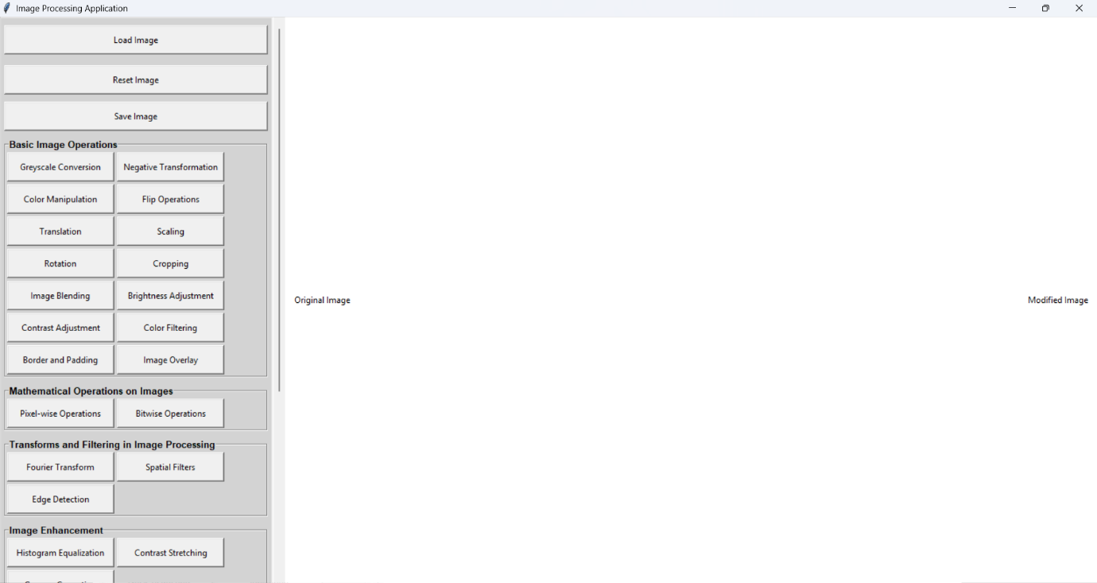

The application layout consists of a clean, structured interface that categorizes functionalities into distinct sections. Each section is represented by labeled buttons that perform specific image processing tasks. The top section includes buttons for image loading, resetting, and saving. Subsequent sections provide categorized tools for basic image operations, mathematical operations, transforms, image enhancement, and more.

1. Layout Application with Image

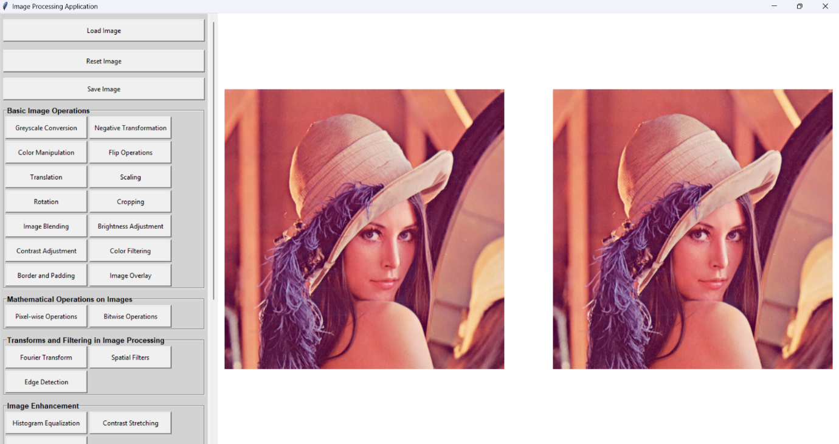

When an image is loaded, the application dynamically adjusts to display the image within the central workspace. The surrounding buttons remain accessible for immediate interaction with the loaded image. This ensures seamless transitions between operations.

### Layout Tools

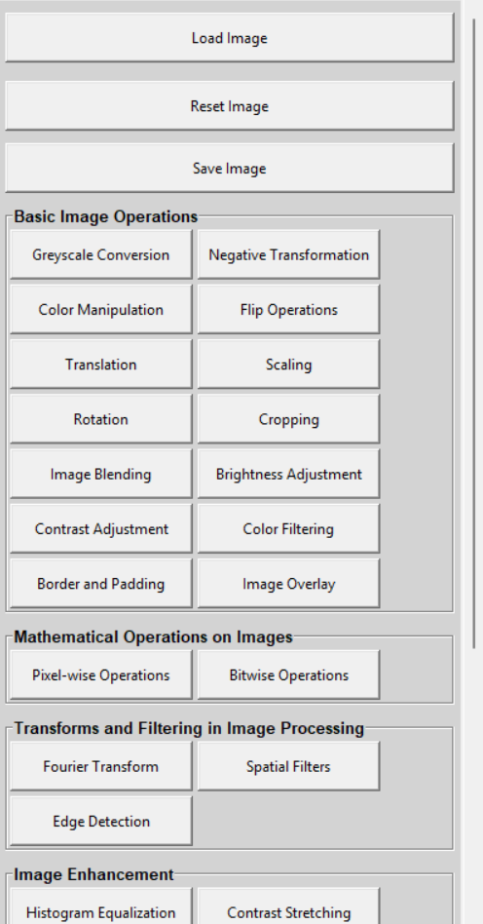

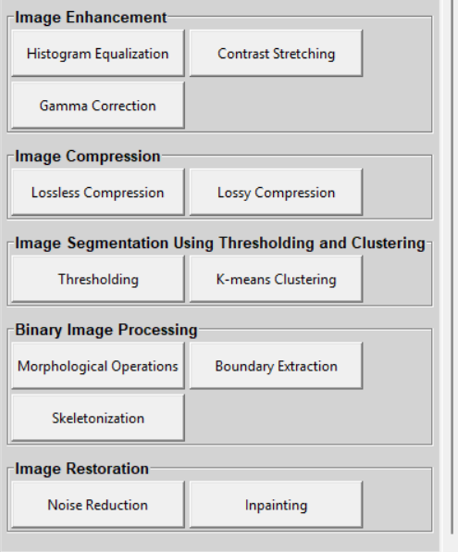

* **Basic Image Operations:** Includes grayscale conversion, negative transformation, color manipulation, and more.
* **Mathematical Operations on Images:** Offers pixel-wise and bitwise operations.
* **Transforms and Filtering in Image Processing:** Includes Fourier transform and edge detection.
* **Image Enhancement:** Features histogram equalization, contrast stretching, and gamma correction.
* **Image Compression:** Includes lossless and lossy compression.
* **Image Segmentation Using Thresholding and Clustering:** Offers thresholding and k-means clustering.
* **Binary Image Processing:** Includes morphological operations and skeletonization.
* **Image Restoration:** Provides noise reduction and inpainting tools.
* **Image Matching:** Features tools for feature detection and template matching.

### Layout Chapter I - Basic Image Operation

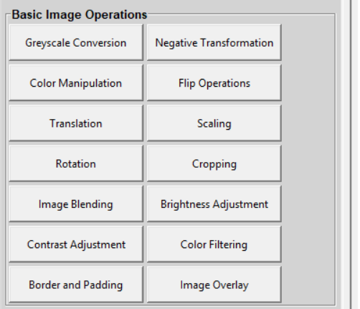

The interface for basic image operations provides buttons for tasks like grayscale conversion, flipping, scaling, and cropping. Users can click each button to perform specific transformations on the loaded image.

### Layout Chapter II - Mathematical Operations on Image

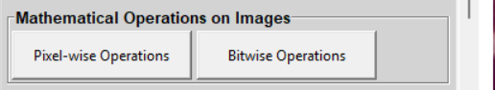

This layout includes pixel-wise and bitwise operations. Each button represents a mathematical function applied directly to the image pixels.

### Layout Chapter III - Transforms and Filtering in Image Processing

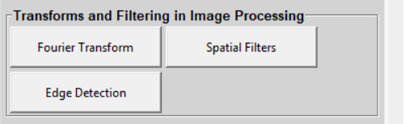

Buttons for applying Fourier transforms, spatial filters, and edge detection are present here. Each tool allows users to analyze and modify the frequency domain or spatial aspects of the image.

### Layout Chapter IV - Image Enhancement

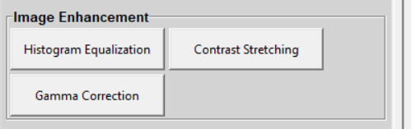

The image enhancement section includes buttons for histogram equalization, contrast stretching, and gamma correction to improve the visual quality of images.

### Layout Chapter V - Image Compression



This layout categorizes tools for lossless and lossy compression, enabling users to reduce image file sizes while preserving quality.

### Layout Chapter VI - Image Segmentation Using Thresholding and Clustering

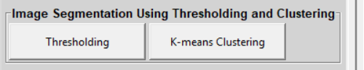

Thresholding and k-means clustering tools are accessible for dividing images into meaningful segments.

### Layout Chapter VII - Binary Image Processing

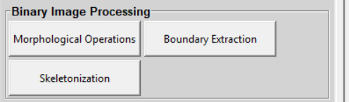

Buttons here include morphological operations, boundary extraction, and skeletonization for processing binary images.

### Layout Chapter VIII - Image Restoration

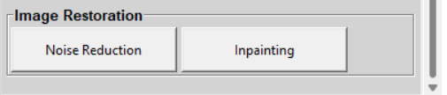

Tools for noise reduction and inpainting are included for restoring and improving image clarity.

### Layout Chapter IX - Image Matching



Feature detection and template matching buttons allow users to identify and compare patterns in images.

## Buttons

### Load Image



Load Image Allows users to load an image from their local storage for processing.

### Reset Image



Reset Image Resets the current image to its original state.

### Save Image



Save Image Saves the processed image to local storage.

### Button Chapter I - Basic Image Operation - Greyscale Conversion

Applies a negative transformation to the image.

### Button Chapter I - Basic Image Operation – Negative Transformation

Applies a negative transformation to the image.

### Button Chapter I - Basic Image Operation – Color Manipulation

Allows users to adjust the image’s color properties.

### Button Chapter I - Basic Image Operation – Flip Operations

Flips the image horizontally or vertically.

### Button Chapter I - Basic Image Operation – Translation

Shifts the image position within the workspace.

### Button Chapter I - Basic Image Operation – Scaling



Scaling Resizes the image dimensions.

### Button Chapter I - Basic Image Operation – Rotation



Rotates the image by a specified angle.

### Button Chapter I - Basic Image Operation – Cropping

Cropping Crops the Image.

### Button Chapter I - Basic Image Operation – Image Blending

Image Blending Blends the loaded image with another.

### Button Chapter I - Basic Image Operation – Brightness Adjustment

Brightness Adjustment Adjusts the image brightness levels.

### Button Chapter I - Basic Image Operation – Contrast Adjustment

Contrast Adjustment Modifies the contrast of the image.

### Button Chapter I - Basic Image Operation – Color Filtering

Color Filtering Applies filters to highlight specific colors in the image.

### Button Chapter I - Basic Image Operation – Border and Padding

Border and Padding Adds borders or padding to the image.

### Button Chapter I - Basic Image Operation – Image Overlay



Image Overlay Adds another images to the image.

### Button Chapter II - Mathematical Operations on Image – Pixel-wise Operations

Pixel-wise Operations Applies operations on a per-pixel basis.

### Button Chapter II - Mathematical Operations on Image – Bitwise Operations

Bitwise Operations Performs bitwise manipulations on the image pixels.

### Button Chapter III - Transforms and Filtering in Image Processing – Fourier Transform

Fourier Transform Applies Fourier transform for frequency domain analysis.

### Button Chapter III - Transforms and Filtering in Image Processing – Spatial Filters

Spatial Filters Applies spatial filters for smoothing or sharpening the image.

### Button Chapter III - Transforms and Filtering in Image Processing – Edge Detection

Edge Detection Highlights edges within the image.

### Button Chapter IV - Image Enhancement – Histogram Equalization

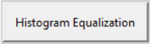

Histogram Equalization Enhances the image by equalizing its histogram.

### Button Chapter IV - Image Enhancement – Contrast Stretching

Contrast Stretching Improves image contrast by stretching intensity levels.

### Button Chapter IV - Image Enhancement – Gamma Correction

Gamma Correction Applies gamma correction to adjust image brightness non-linearly.

### Button Chapter V - Image Compression – Lossless Compression

Lossless Compression Compresses the image without losing quality.

### Button Chapter V - Image Compression – Lossy Compression

Lossy Compression Reduces image file size with potential quality loss.

### Button Chapter VI - Image Segmentation Using Thresholding and Clustering - Thresholding

Thresholding Segments the image based on intensity thresholds.

### Button Chapter VI - Image Segmentation Using Thresholding and Clustering – K-Means Clustering

K-Means Clustering Clusters image pixels into groups based on similarity.

### Button Chapter VII - Binary Image Processing- Morphological Operations

Morphological Operations Applies operations like dilation and erosion on binary images.

### Button Chapter VII - Binary Image Processing – Boundary Extraction



Boundary Extraction Extracts object boundaries from binary images.

### Button Chapter VII - Binary Image Processing - Skeletonization

Skeletonization Reduces binary images to their skeletal structure.

### Button Chapter VIII - Image Restoration – Noise Reduction

Noise Reduction Reduces noise in the image.

### Button Chapter VIII - Image Restoration - Inpainting

Inpainting Fills in missing or damaged parts of the image.

### Button Chapter IX - Image Matching - FeatureDetection

Inpainting Fills in missing or damaged parts of the image.

### Button Chapter IX - Image Matching – Template Matching

Template Matching Matches parts of the image to a template.

## Navigation In the System

Navigation In the System The navigation system consists of clickable buttons grouped logically for each chapter. Users can switch between chapters and functionalities seamlessly without reloading the interface.

## Features and Functionality

Features and Functionality The application’s core features include:

* **Basic Image Operations:** Transformation, enhancement, and manipulation tools.
* **Advanced Operations:** Fourier transform, clustering, and feature detection.
* **Customizable Tools:** Adjustable parameters for user-specific requirements.

Use Case Diagram:

* **Image Upload:** User selects an image to load into the application.
* **Processing Operation:** User applies desired tools to modify the image.
* **Result Display:** Processed image is displayed in the workspace.
* **Image Save:** User saves the modified image to their system.

The user-friendly interface ensures all functionalities are easily accessible for effective image processing.

# CHAPTER V HOW TO USE THE SYSTEM

## Chapter I - Basic Image Operation - Greyscale Conversion

**Steps:**

1. Click Load Image.

2. Click on the Grayscale Button.

3. Click Save Image.

**Output:**

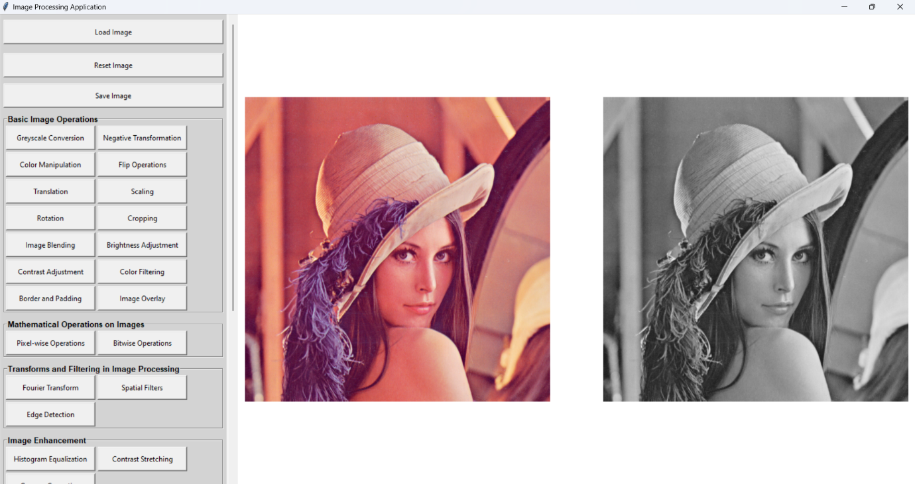

**Result:**

The image is converted to shades of grey, removing all color. Each pixel's intensity represents the brightness, calculated by averaging or using weighted RGB values (e.g., 0.3R + 0.59G + 0.11B). This results in a monochrome image highlighting the structure and texture.

## Chapter I - Basic Image Operation – Negative Transformation

**Steps:**

1. Click Load Image.

2. Click on the Negative Transformation Button.

3. Click Save Image.

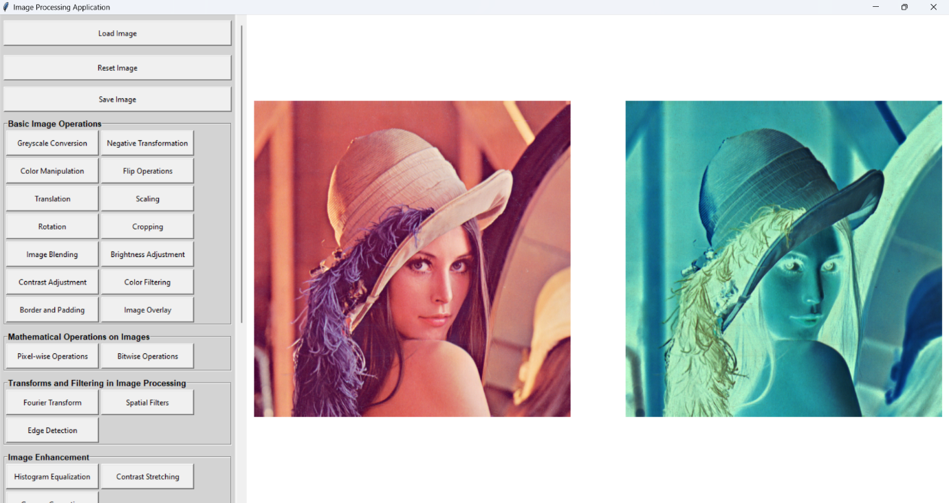**Output:**

**Result:**

The image appears inverted, where bright areas become dark and vice versa. Each pixel value is subtracted from the maximum intensity (e.g., 255 - pixel value for an 8-bit image), creating a photographic negative effect.

## Chapter I - Basic Image Operation – Color Manipulation (10,10,10)

**Steps:**

1. Click Load Image.

2. Click on the Color Manipulation Button.

3. Enter the value for the red intensity.

4. Enter the value for the green intensity.

5. Enter the value for the blue intensity.

6. Click Save Image.

**Output:**

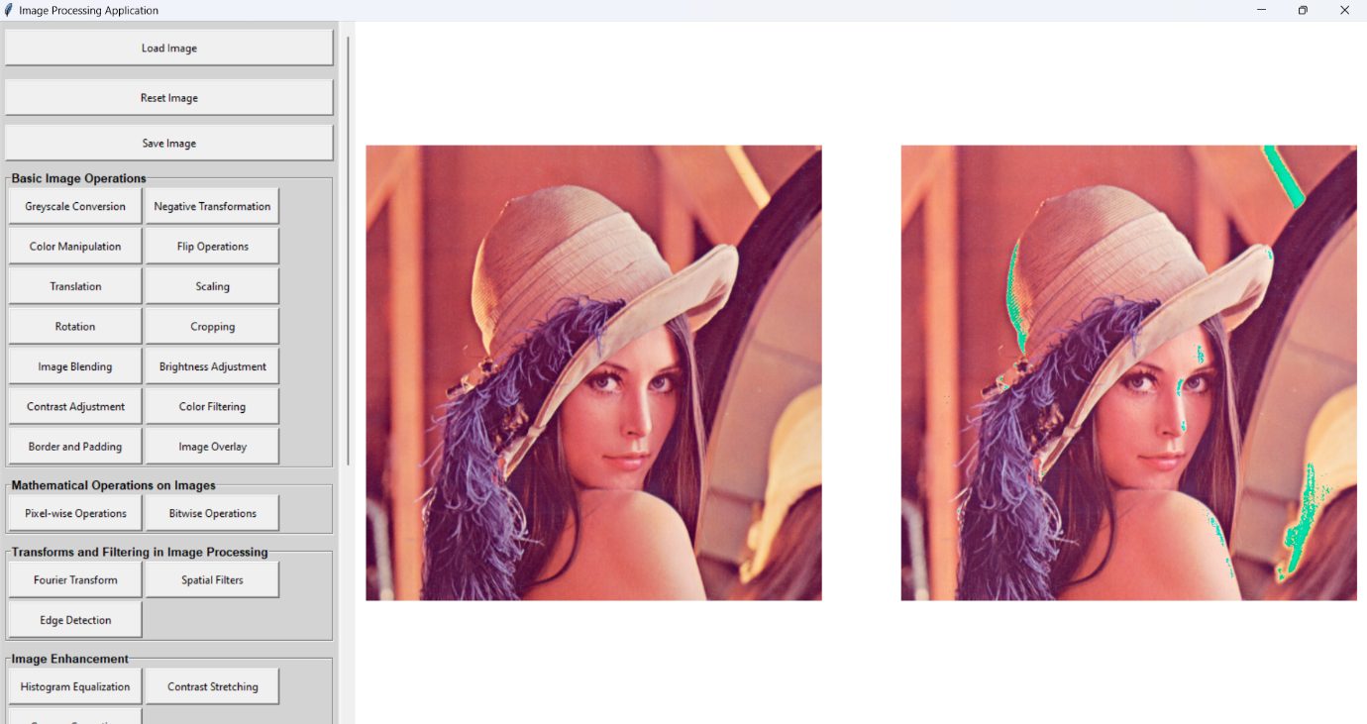

**Result:**

* Specific Color Changes:

Selected regions are recolored to red, blue, yellow, or any specified color, transforming the visual focus.

* RGB Intensity Adjustment:

Individual color channels are brightened or dimmed, altering the image's overall tone, such as making it warmer (red emphasis) or cooler (blue emphasis).

## Chapter I - Basic Image Operation – Flip Operations

**Steps:**

1. Click Load Image.

2. Click on the Flip Operations Button.

3. Choose whether to flip the image horizontally, vertically, or diagonally.

4. Click Save Image.

### Vertical Flip

**Output:**

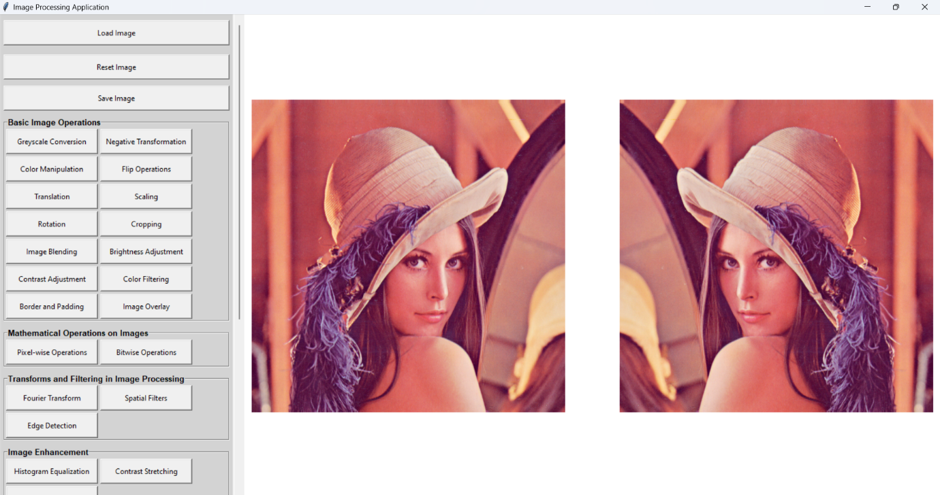

**Result:**

Horizontal Flip: The image is mirrored along the vertical axis, swapping the left and right sides.

### Diagonal Flip

**Output:**

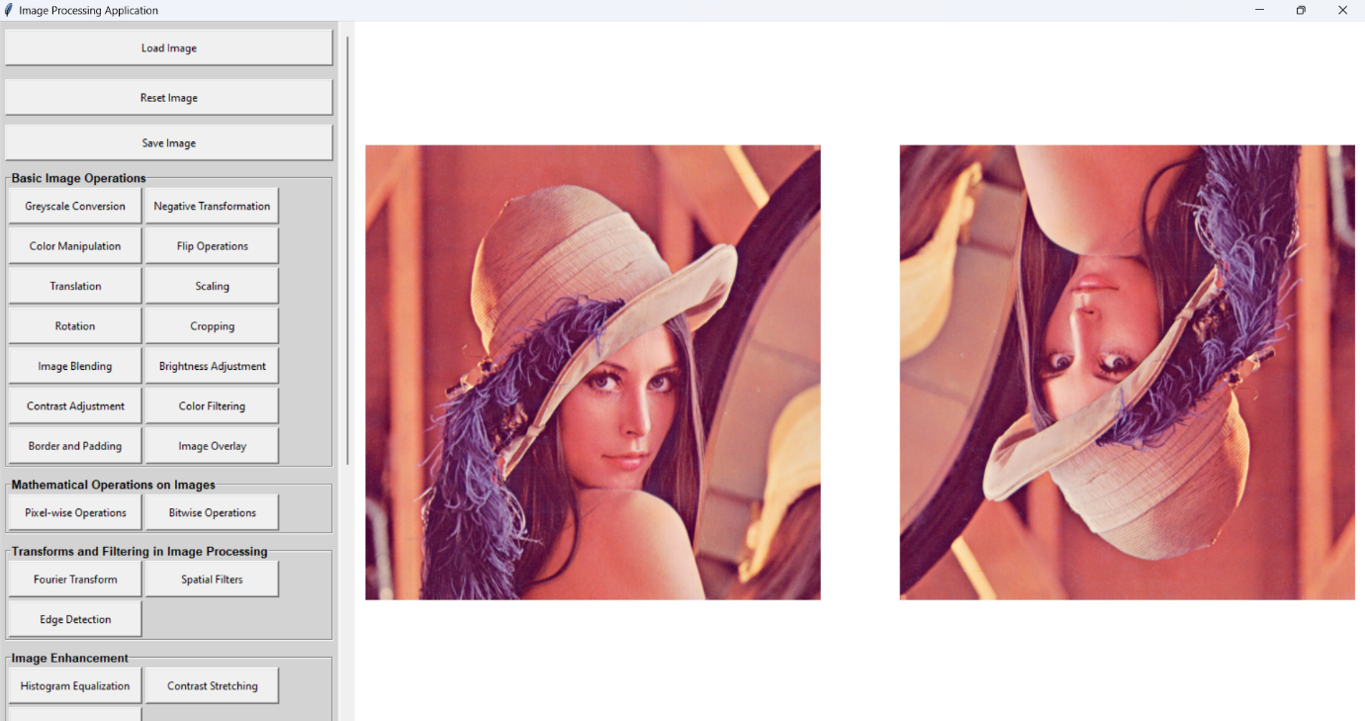

**Result:**

Vertical Flip: The image is mirrored along the horizontal axis, swapping the top and bottom.

### Horizontal Flip

**Output:**



**Result:**

Diagonal Flip: A combination of horizontal and vertical flips, resulting in a 180-degree rotation.

## Chapter I - Basic Image Operation – Translation (20,20)

**Steps:**

1. Click Load Image.

2. Click on the Translation Button.

3. Enter the horizontal offset.

4. Enter the vertical offset.

5. Click Save Image.

**Output:**

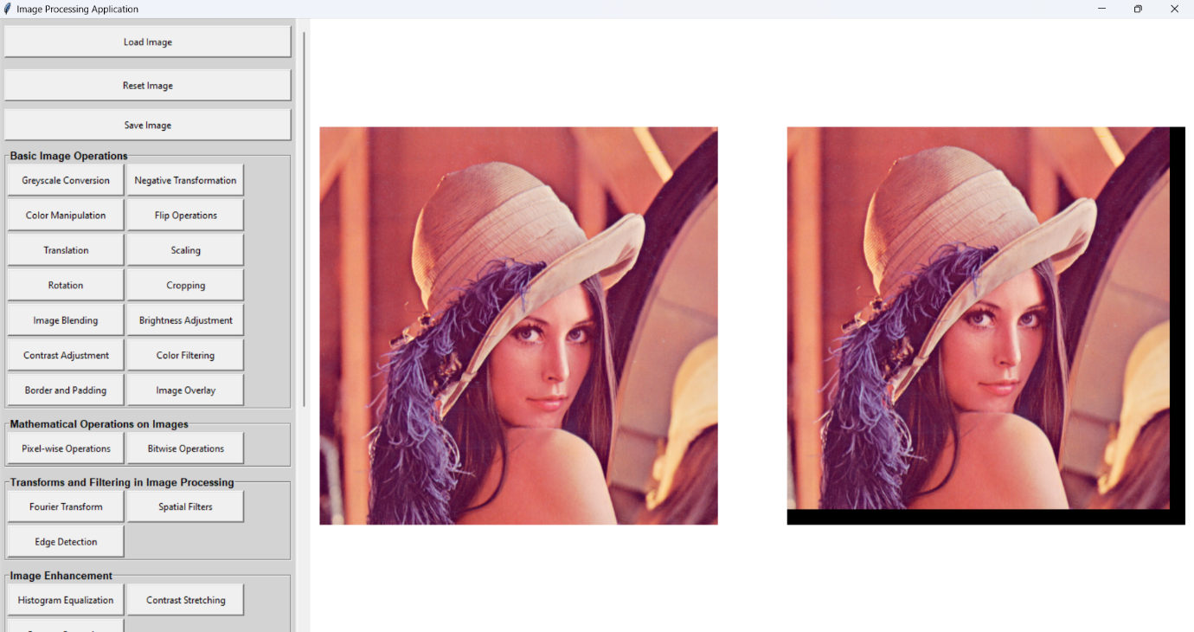

**Result:**

The image is shifted horizontally, vertically, or diagonally by a defined offset. This creates the effect of moving the image within the frame, leaving blank areas or wrapping around depending on the implementation.

## Chapter I - Basic Image Operation – Scaling (200x200)

**Steps:**

1. Click Load Image.

2. Click on the Scaling Button.

3. Enter the new width of the image.

4. Enter the new height of the image.

5. Click Save Image.

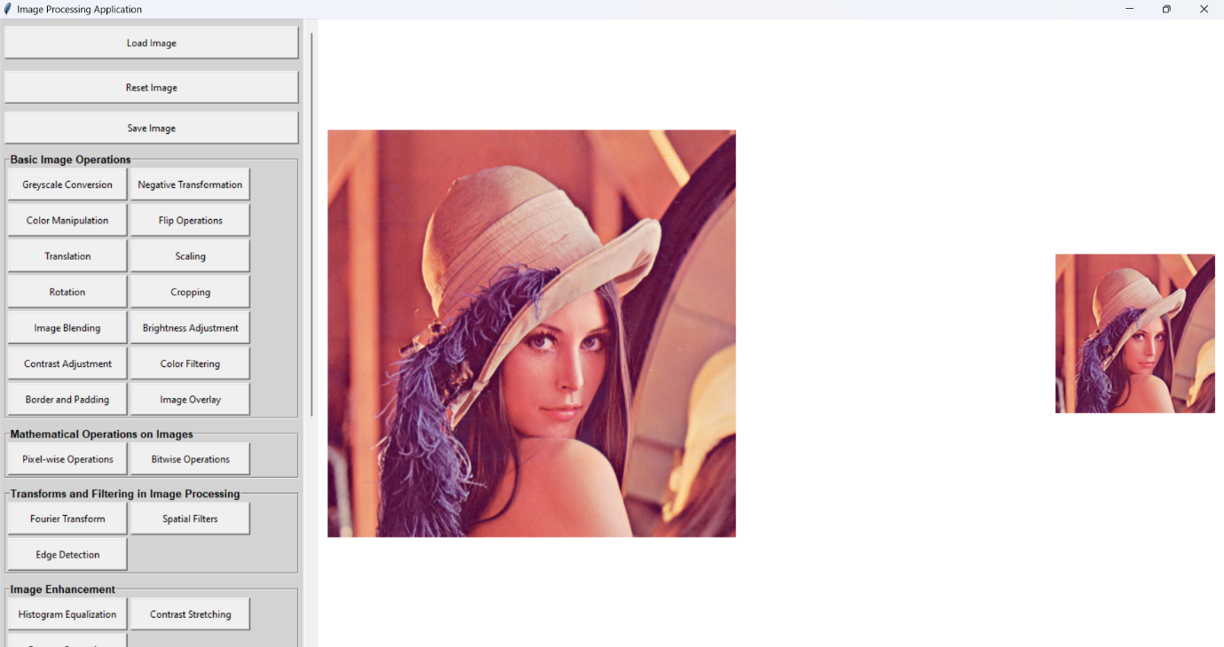**Output:**

**Result:**

The image is resized to a new width and height. If the aspect ratio is maintained, the image looks proportional; otherwise, it may appear stretched or squished.

## Chapter I - Basic Image Operation – Rotation

**Steps:**

1. Click Load Image

2. Click on the Cropping Button

3. Enter the left coordinate

4. Enter the top coordinate

5. Enter the right coordinate

6. Enter the bottom coordinate

7. Click Save Image

### Rotation

**Output:**

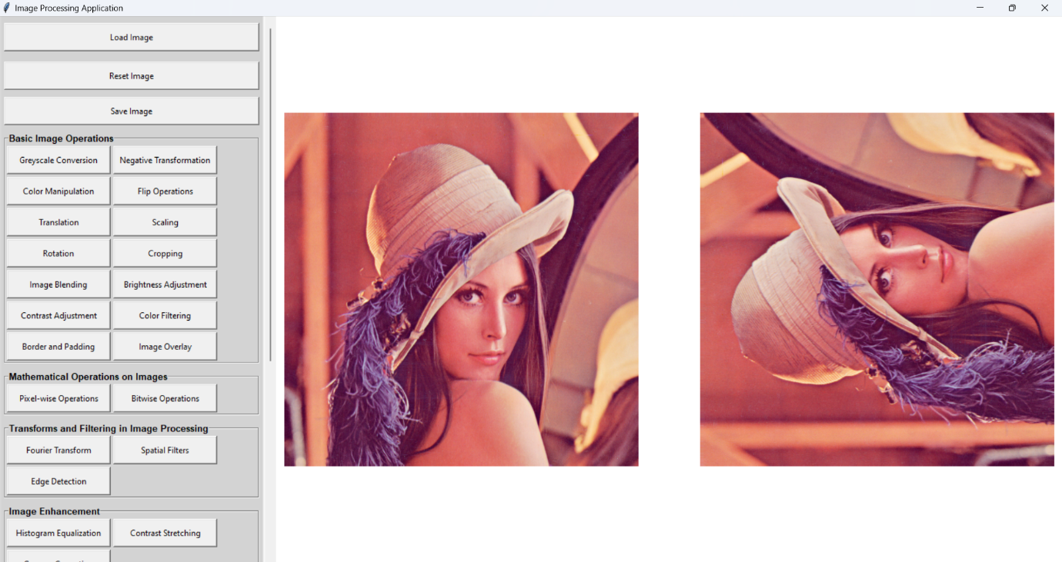

### Counter Clock Wise 90

**Output:**

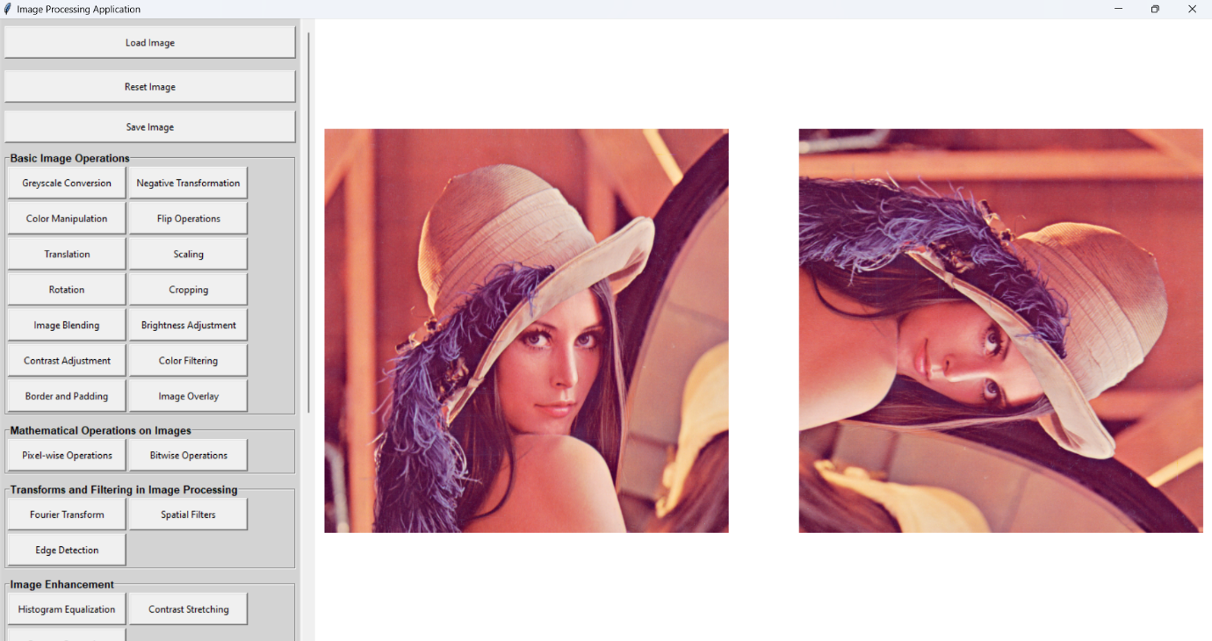

**Result:**

The image is rotated by a specified angle (e.g., 90°, 45°) either clockwise or counterclockwise, creating a tilted or reoriented view. Unused areas may be filled with a background color or left blank.

## Chapter I - Basic Image Operation – Cropping

**Steps:**

1. Click Load Image

2. Click on the Cropping Button

3. Enter the left coordinate

4. Enter the top coordinate

5. Enter the right coordinate

6. Enter the bottom coordinate

7. Click Save Image

**Output:**

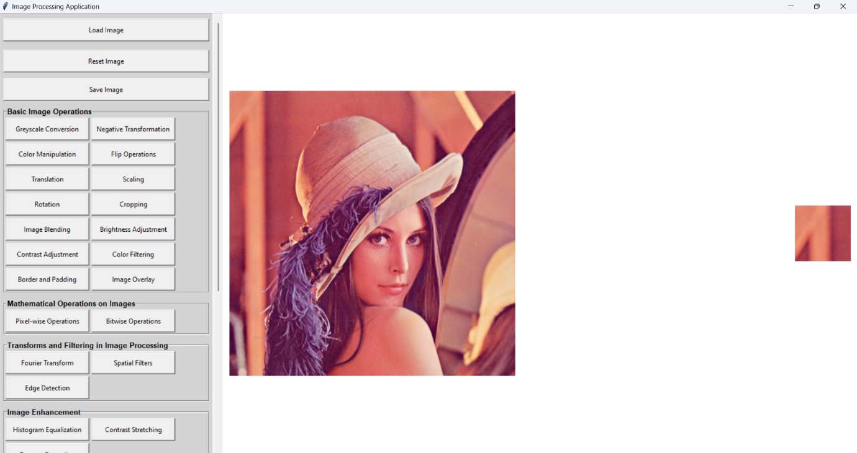

**Result:**

A specific portion of the image is extracted, isolating a region of interest. Non-selected areas are removed, leaving only the selected rectangular or custom-shaped region.

## Chapter I - Basic Image Operation – Image Blending

**Steps:**

1. Click Load Image

2. Click on the Image Blending Button

3. Choose another image to blend with the first image

4. Enter the blending ratio

5. Click Save Image

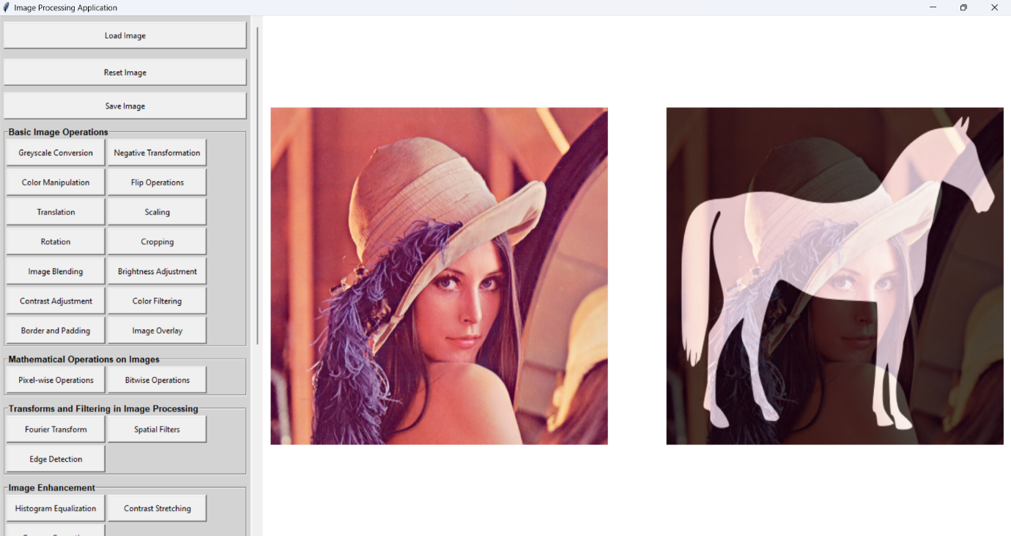**Output:**

**Result:**

Two images are combined with adjustable blending ratios. For example, a 50-50 blend creates a semi-transparent overlay of both images, producing a merged effect.

## Chapter I - Basic Image Operation – Brightness Adjustment

**Steps:**

1. Click Load Image

2. Click on the Brightness Adjustment Button

3. Enter the brightness factor

4. Click Save Image

**Output:**

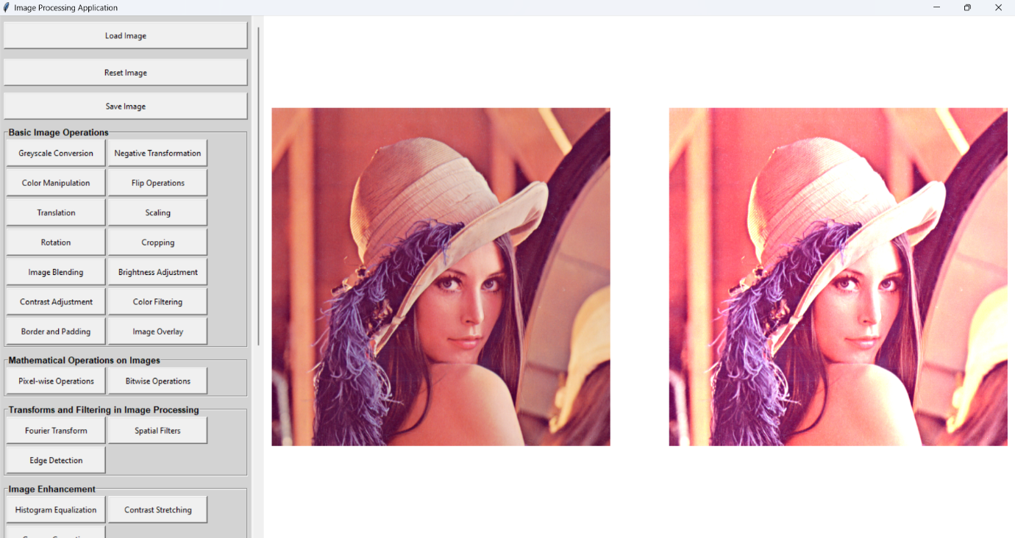

**Result:**

The overall brightness of the image increases or decreases. Adding a constant makes the image lighter, while subtracting a constant darkens it.

## Chapter I - Basic Image Operation – Contrast Adjustment

Output:

Result:

Chapter I - Basic Image Operation – Color Filtering

Chapter I - Basic Image Operation – Border and Padding

Chapter I - Basic Image Operation – Image Overlay

Image Overlay Adds another images to the image.

4.2.15 Button Chapter II - Mathematical Operations on Image – Pixel-wise Operations

Pixel-wise Operations Applies operations on a per-pixel basis.

4.2.16 Button Chapter II - Mathematical Operations on Image – Bitwise Operations

Bitwise Operations Performs bitwise manipulations on the image pixels.

4.2.17 Button Chapter III - Transforms and Filtering in Image Processing – Fourier Transform

Fourier Transform Applies Fourier transform for frequency domain analysis.

4.2.18 Button Chapter III - Transforms and Filtering in Image Processing – Spatial Filters

Spatial Filters Applies spatial filters for smoothing or sharpening the image.

4.2.19 Button Chapter III - Transforms and Filtering in Image Processing – Edge Detection

Edge Detection Highlights edges within the image.

4.2.20 Button Chapter IV - Image Enhancement – Histogram Equalization

Histogram Equalization Enhances the image by equalizing its histogram.

4.2.21 Button Chapter IV - Image Enhancement – Contrast Stretching

Contrast Stretching Improves image contrast by stretching intensity levels.

4.2.22 Button Chapter IV - Image Enhancement – Gamma Correction

Gamma Correction Applies gamma correction to adjust image brightness non-linearly.

4.2.23 Button Chapter V - Image Compression – Lossless Compression

Lossless Compression Compresses the image without losing quality.

4.2.24 Button Chapter V - Image Compression – Lossy Compression

Lossy Compression Reduces image file size with potential quality loss.

4.2.25 Button Chapter VI - Image Segmentation Using Thresholding and Clustering - Thresholding

Thresholding Segments the image based on intensity thresholds.

4.2.26 Button Chapter VI - Image Segmentation Using Thresholding and Clustering – K-Means Clustering

K-Means Clustering Clusters image pixels into groups based on similarity.

4.2.27 Button Chapter VII - Binary Image Processing- Morphological Operations

Morphological Operations Applies operations like dilation and erosion on binary images.

4.2.28 Button Chapter VII - Binary Image Processing – Boundary Extraction

Boundary Extraction Extracts object boundaries from binary images.

4.2.29 Button Chapter VII - Binary Image Processing - Skeletonization

Skeletonization Reduces binary images to their skeletal structure.

4.2.30 Button Chapter VIII - Image Restoration – Noise Reduction

Noise Reduction Reduces noise in the image.

4.2.31 Button Chapter VIII - Image Restoration - Inpainting

Inpainting Fills in missing or damaged parts of the image.

4.2.32 Button Chapter IX - Image Matching - FeatureDetection

Inpainting Fills in missing or damaged parts of the image.

4.2.33 Button Chapter IX - Image Matching – Template Matching

Template Matching Matches parts of the image to a template.

Grayscale

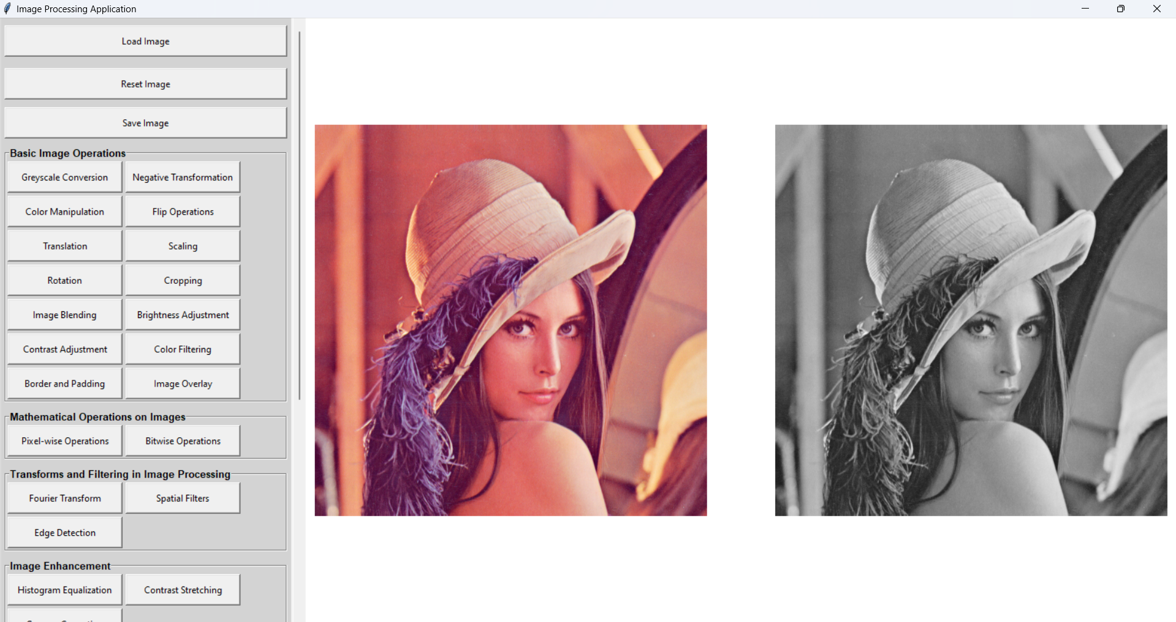

Negative Transformation

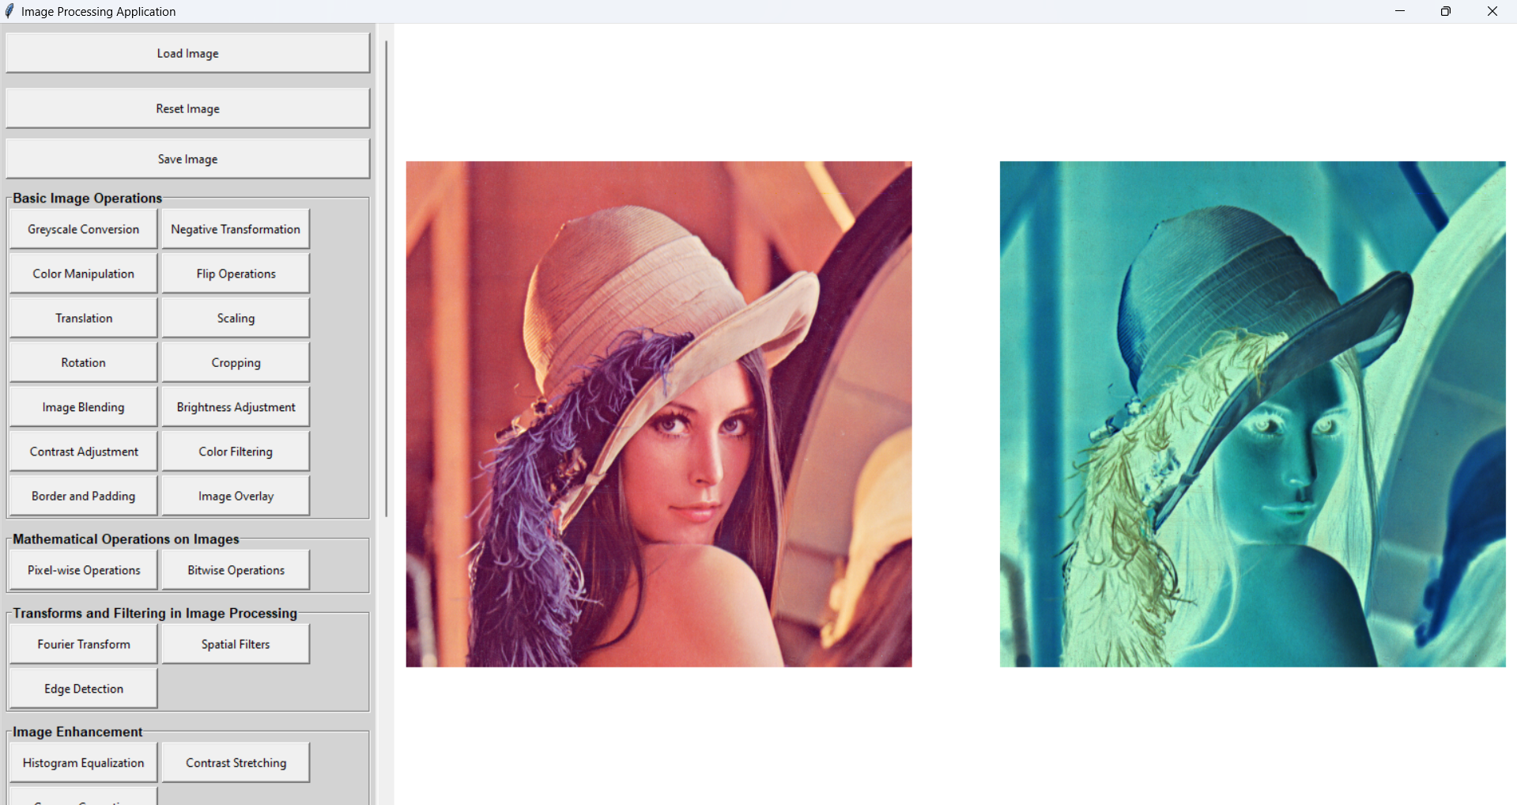

Color Manipulation (10, 10, 10)

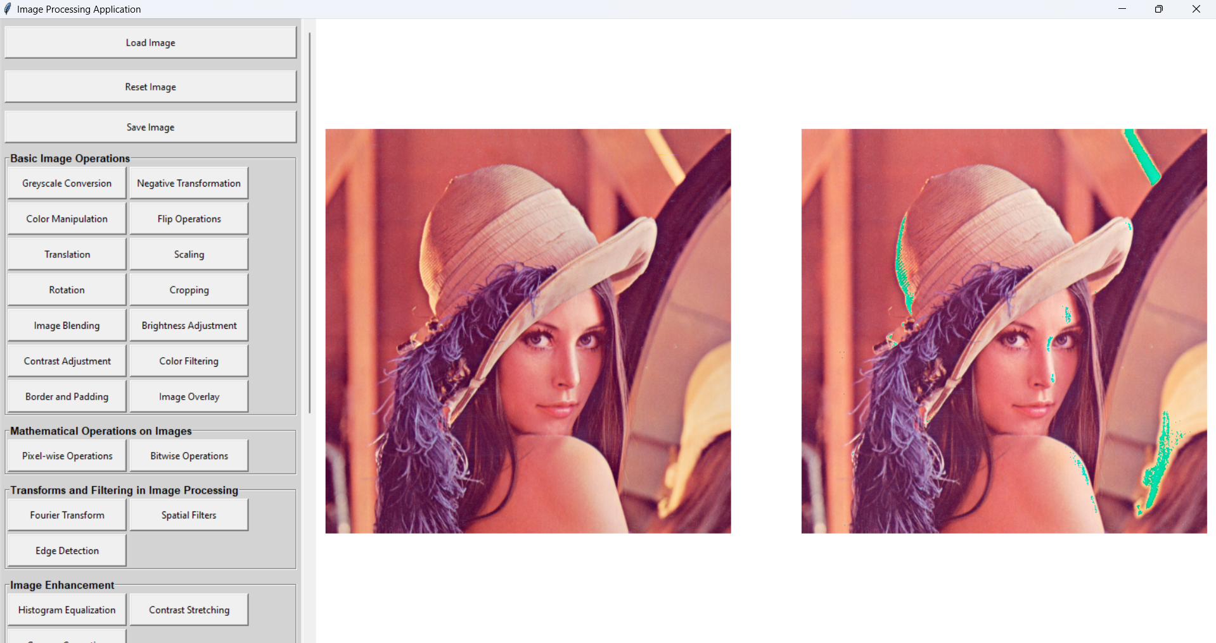

Flip Horizontal

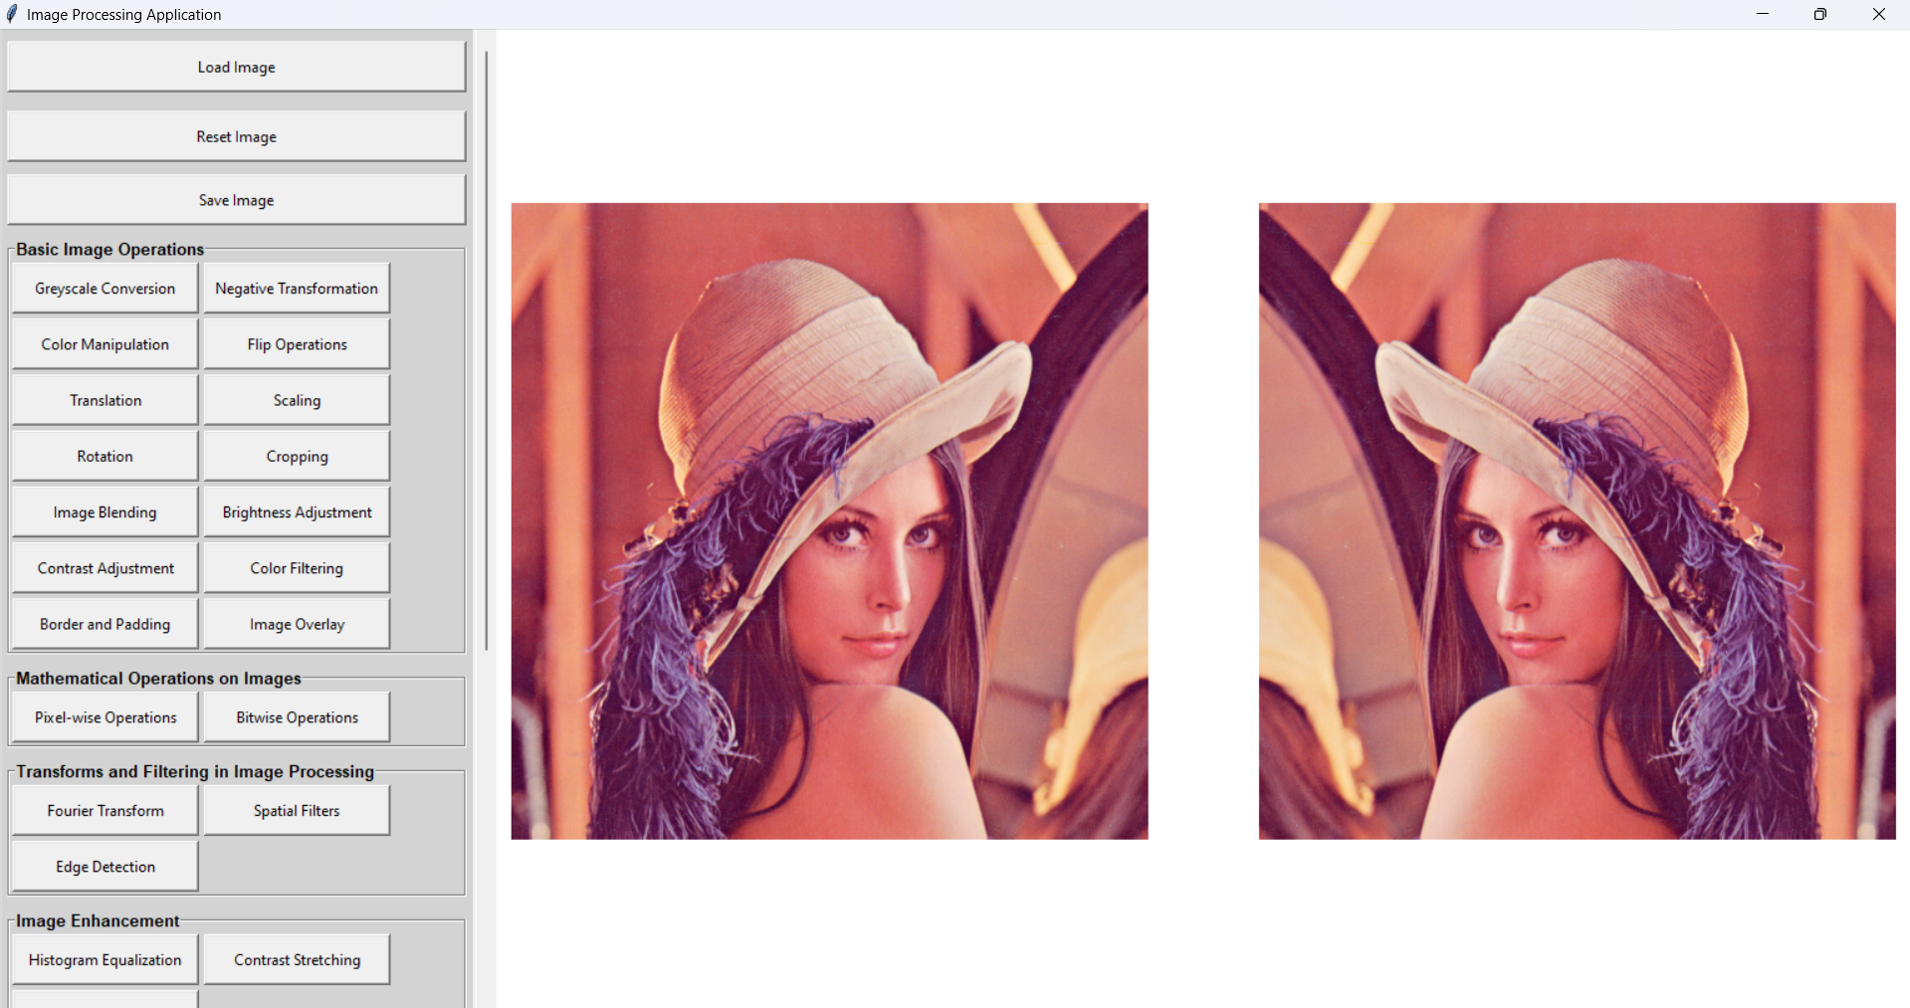

Vertical

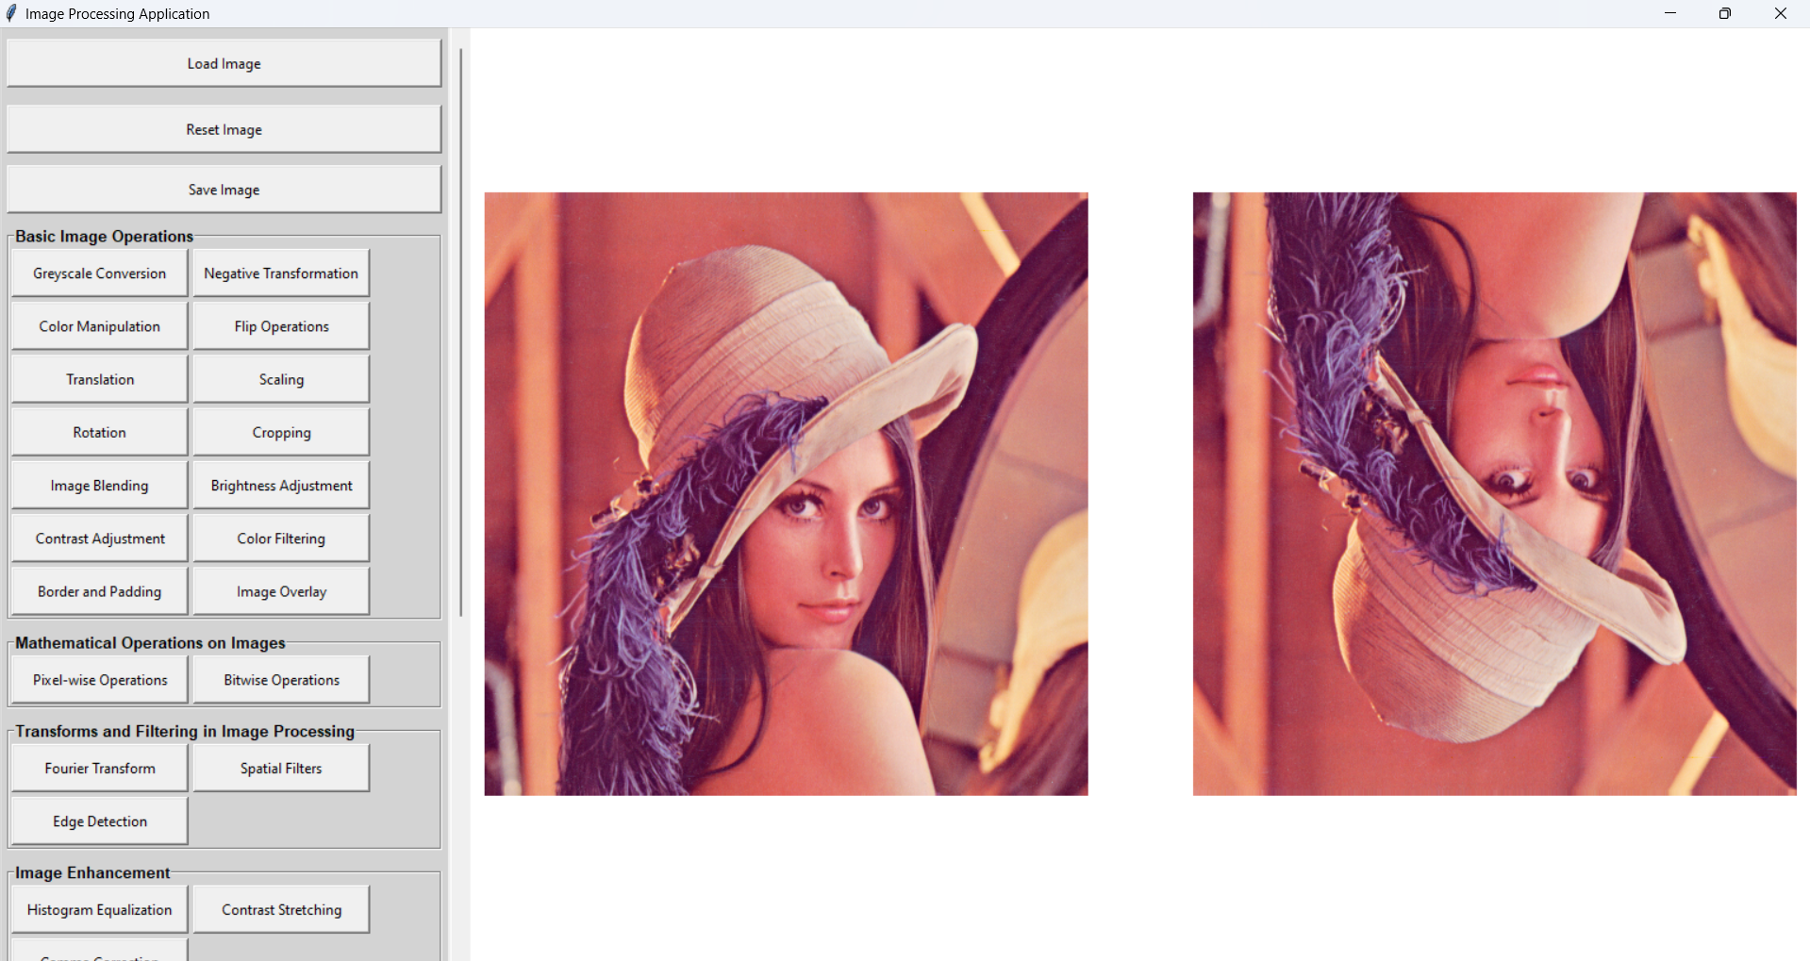

Diagonal

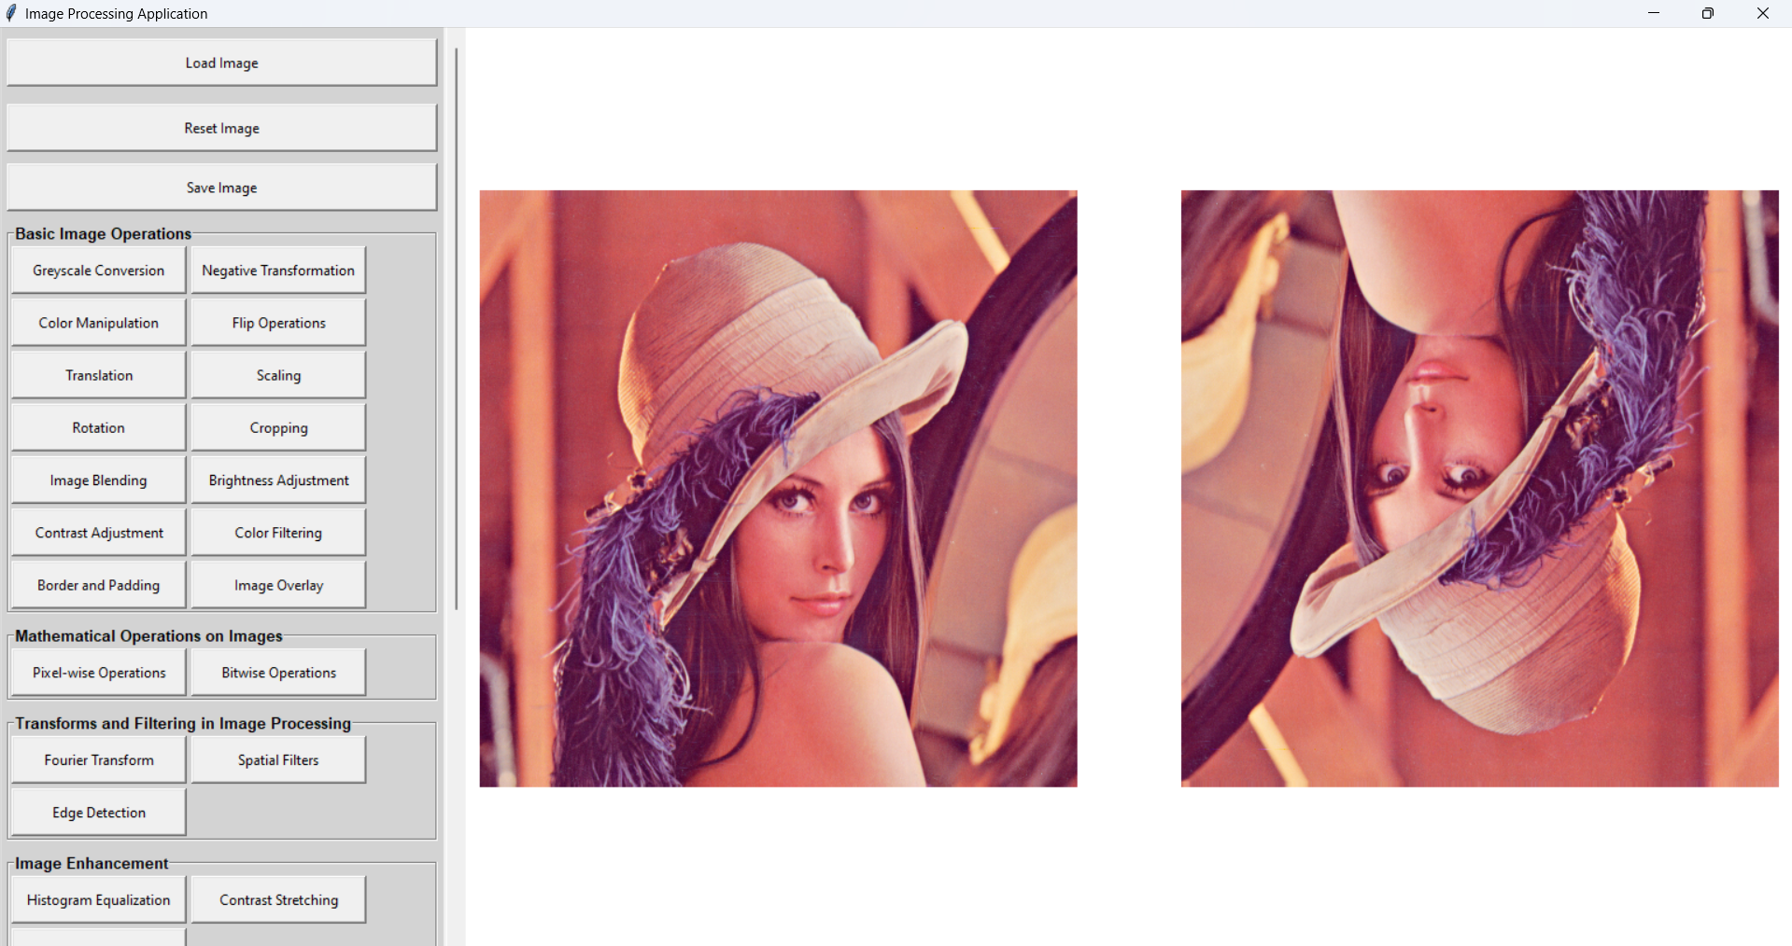

Translation (20, 20)

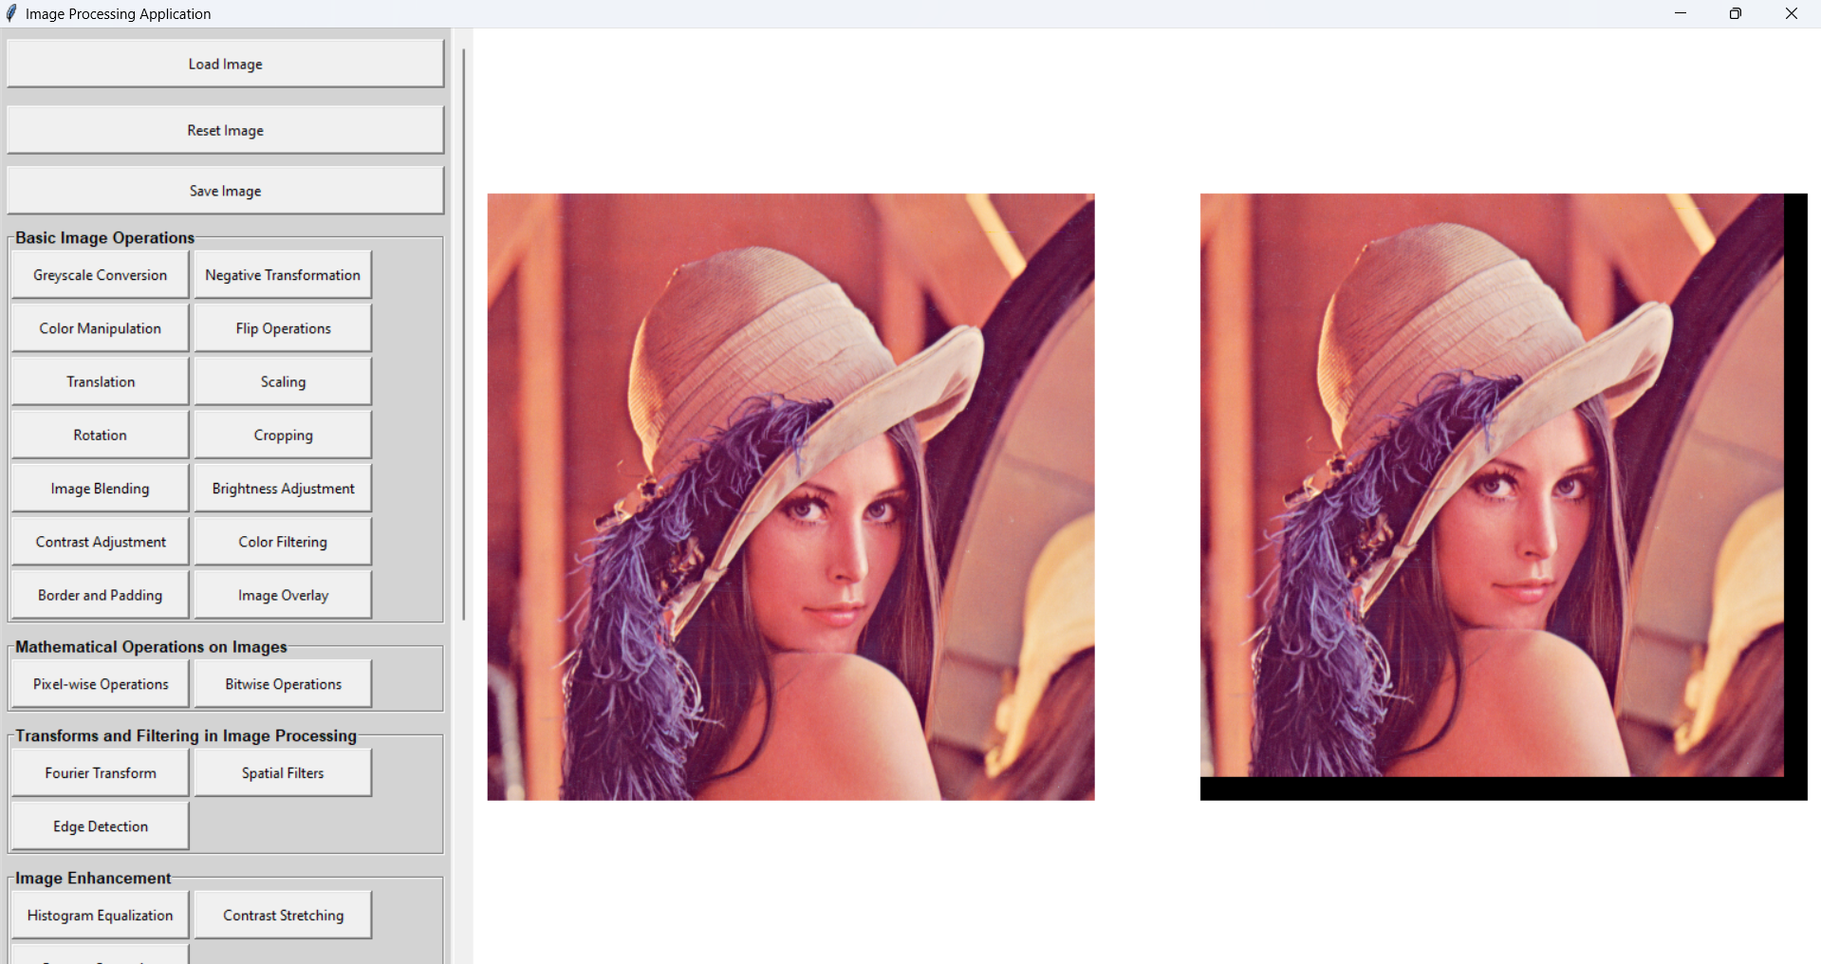

Scaling (200x200)

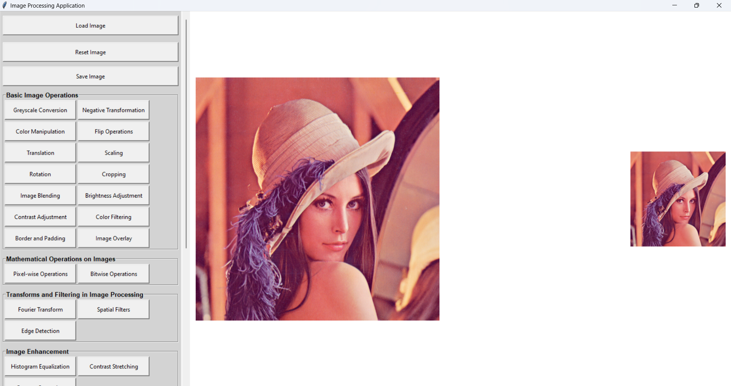

Rotation

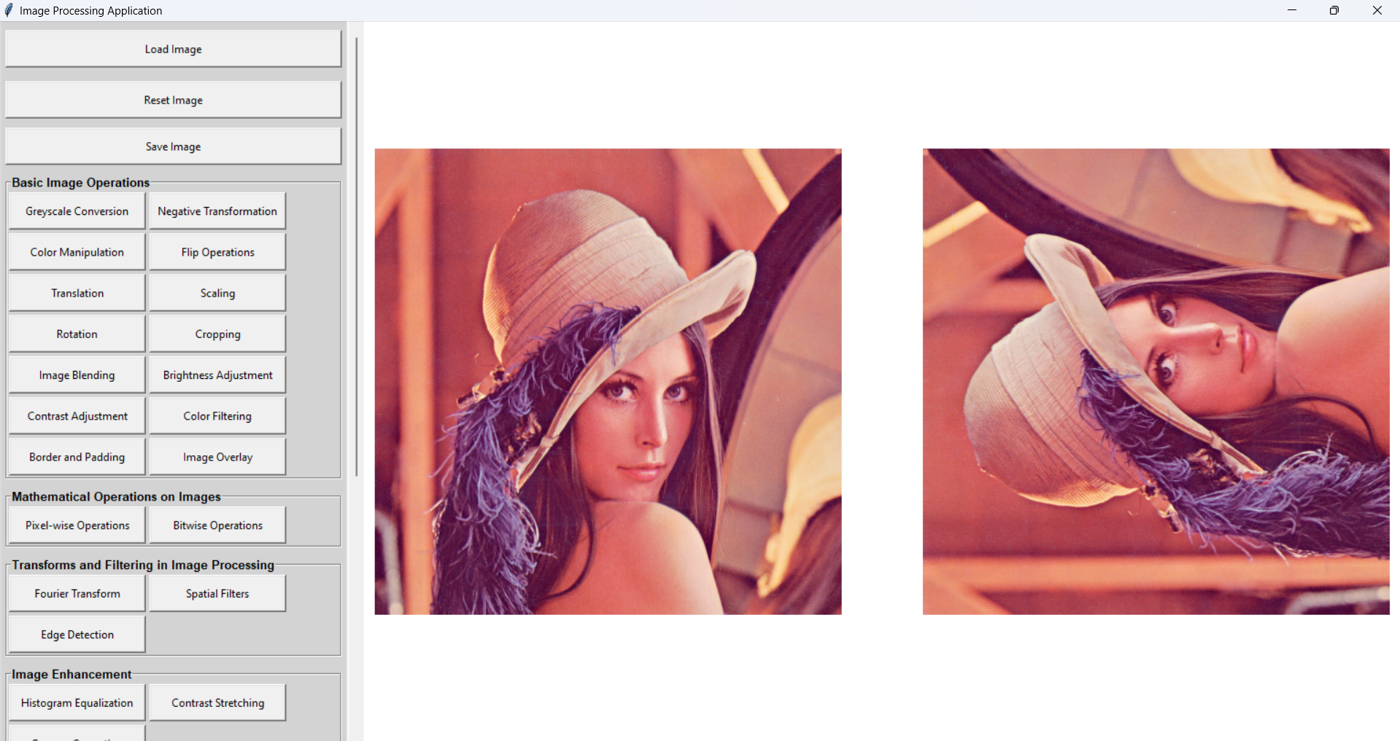

CCW 90

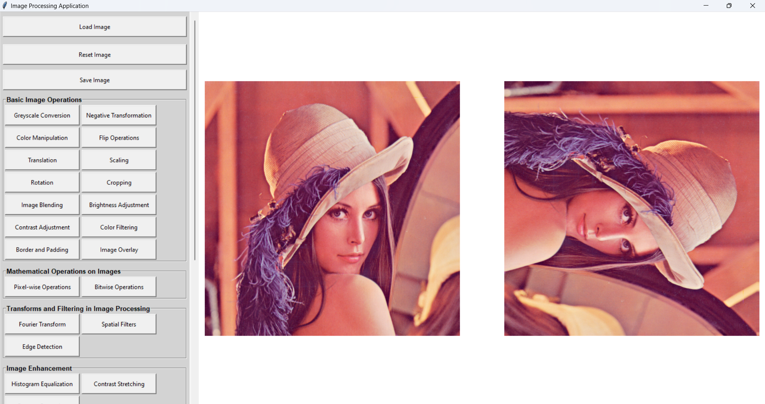

Cropping

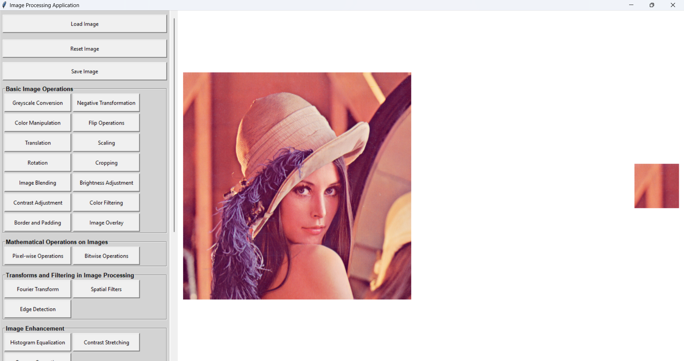

Blending

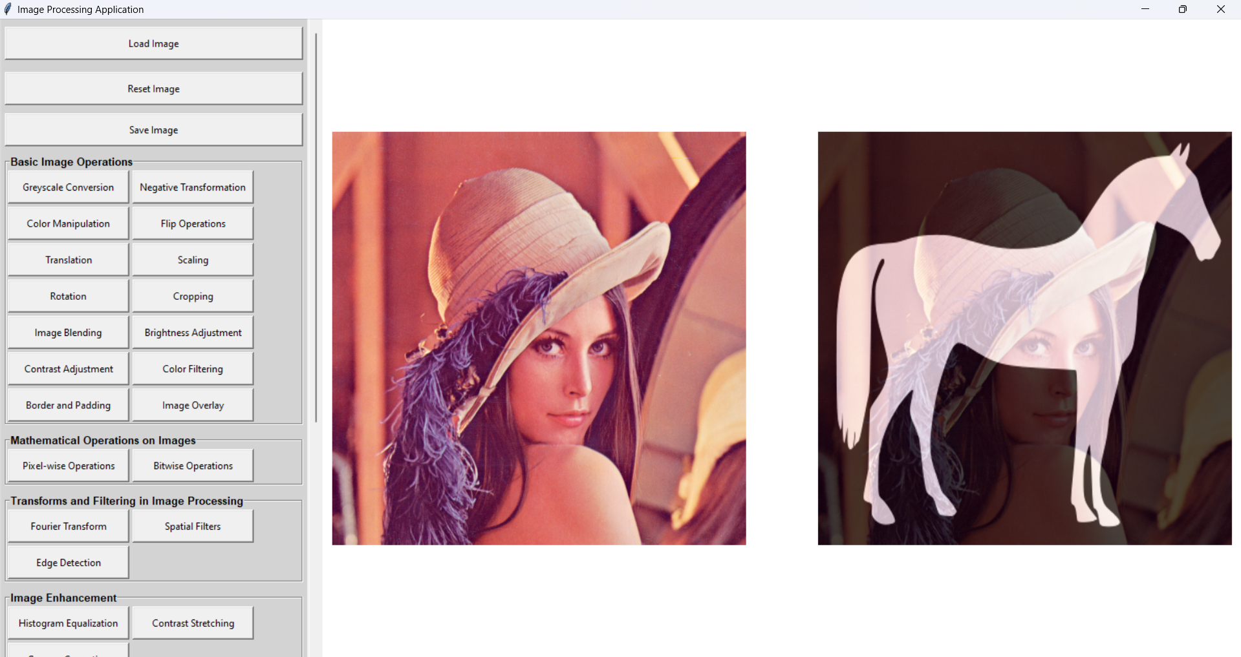

Brightness

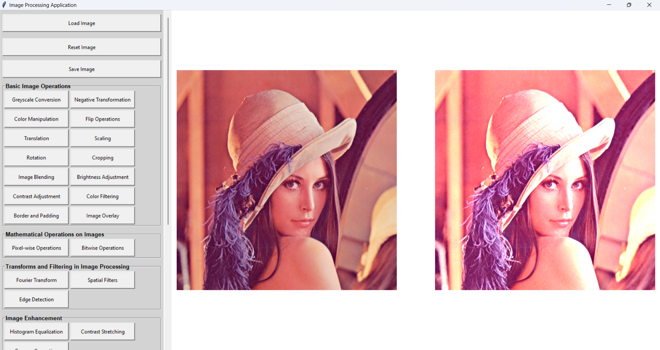

Contrast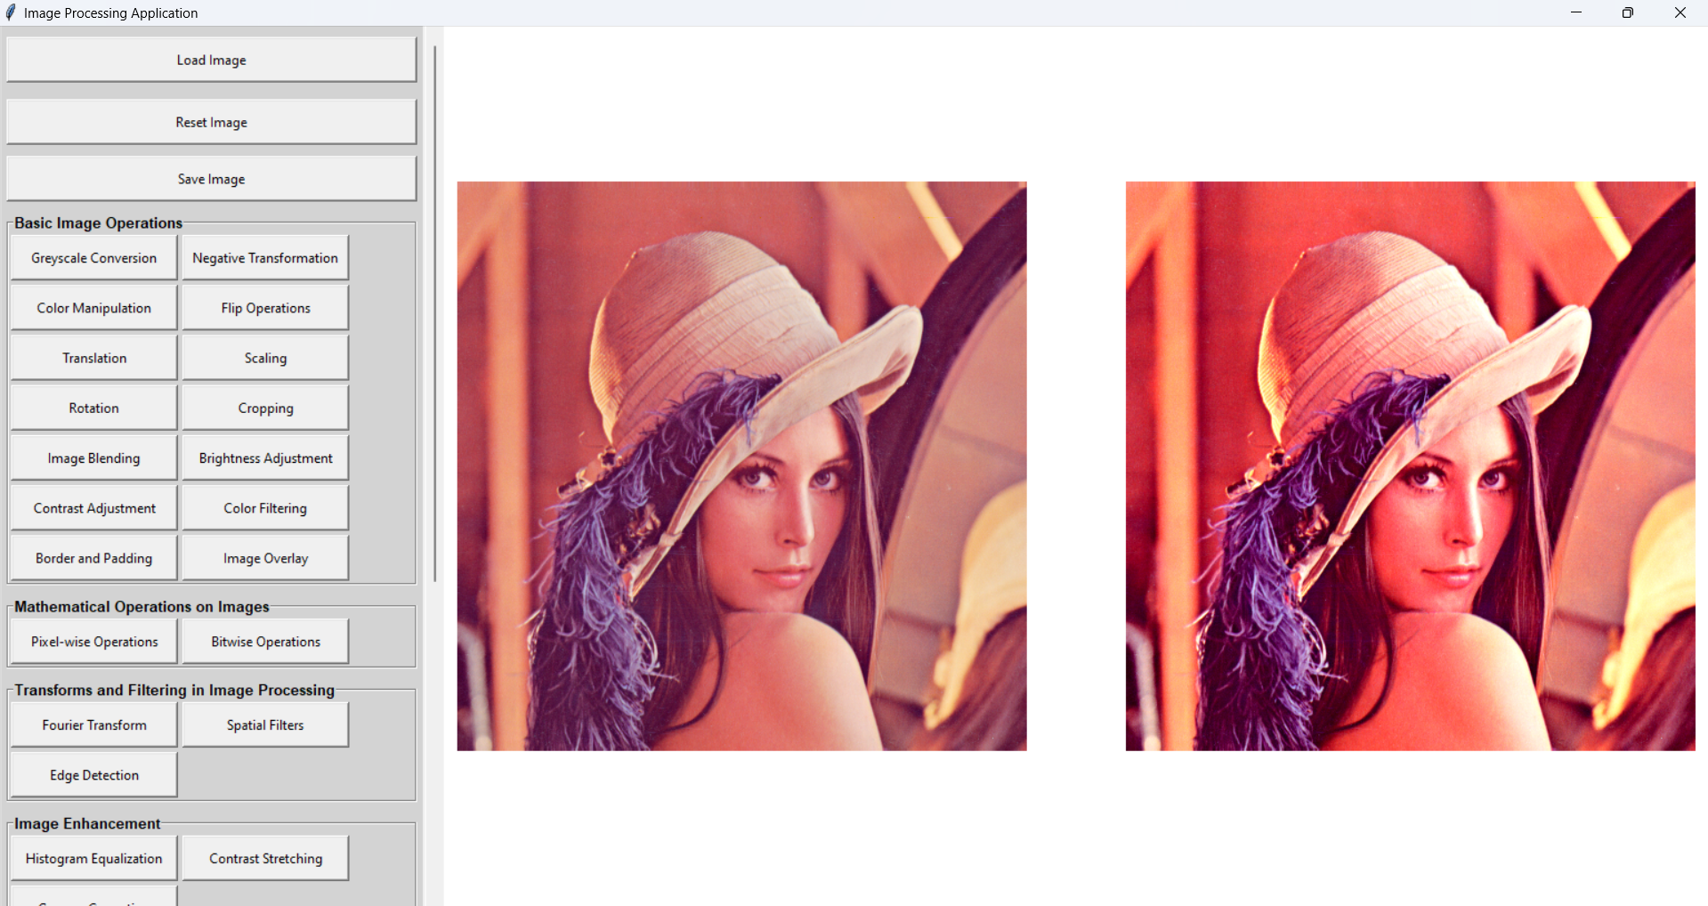

Color filtering

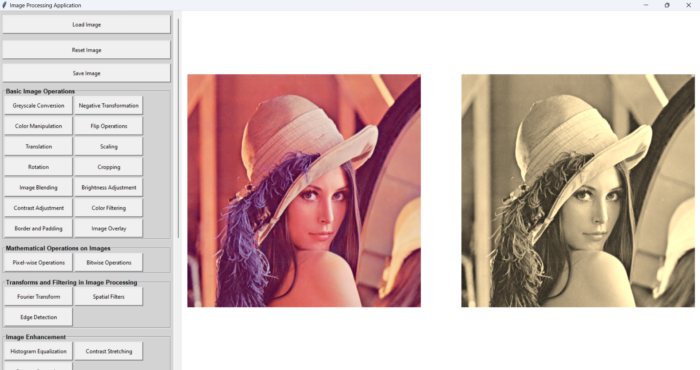

Border and padding

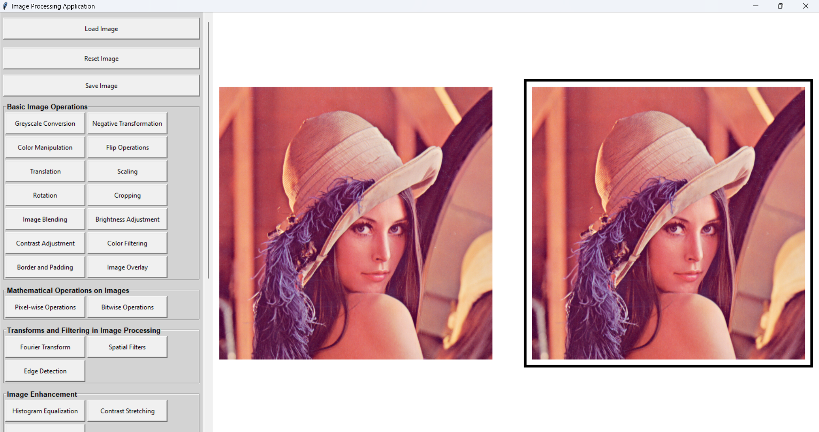

Overlay

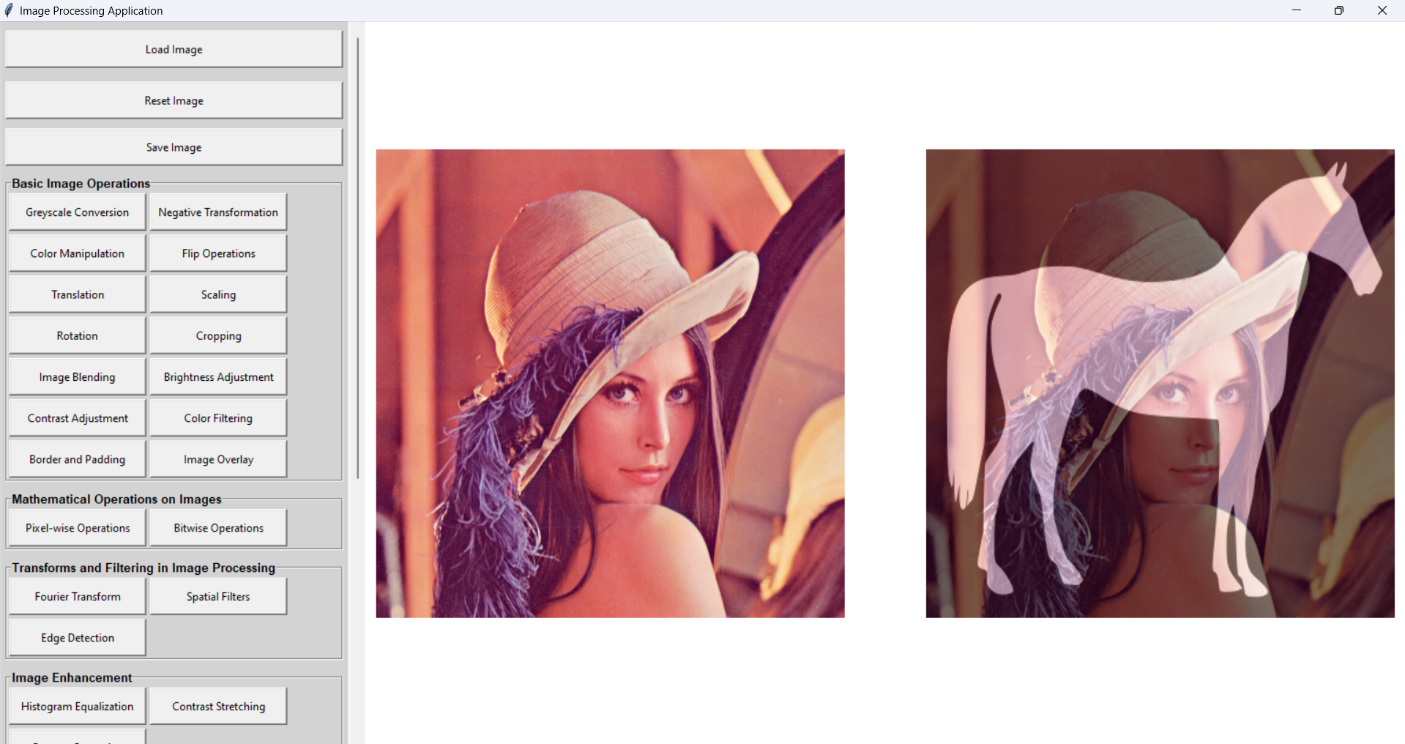

Addition

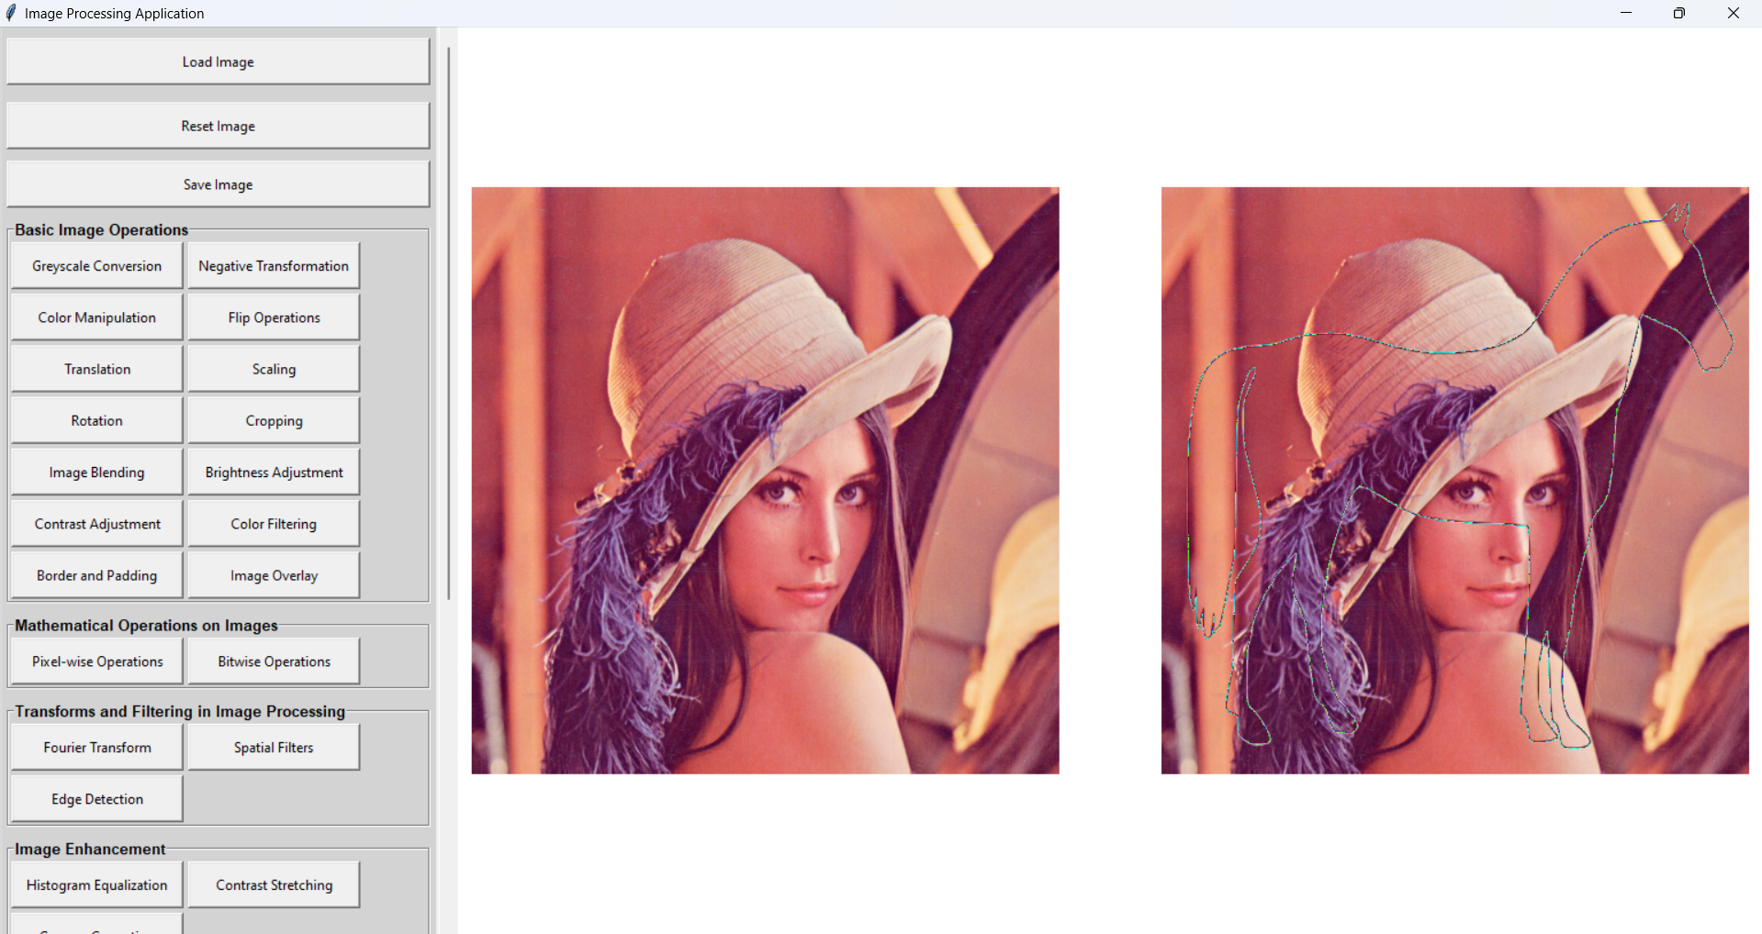

Subtraction

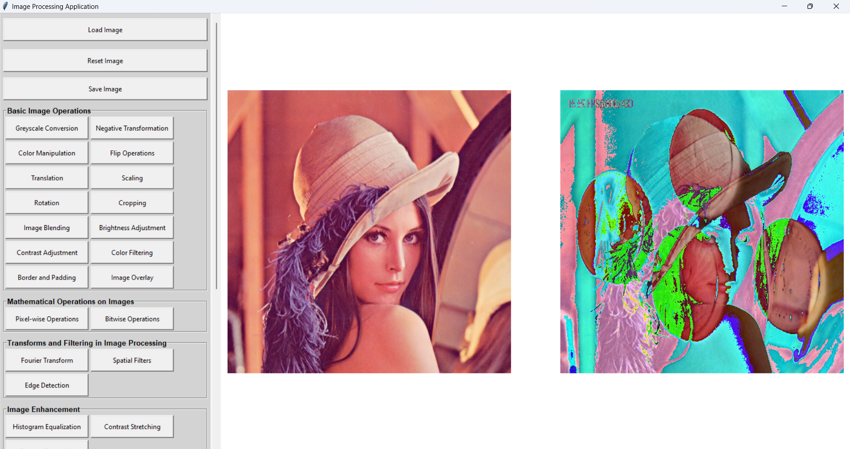

Multiplication

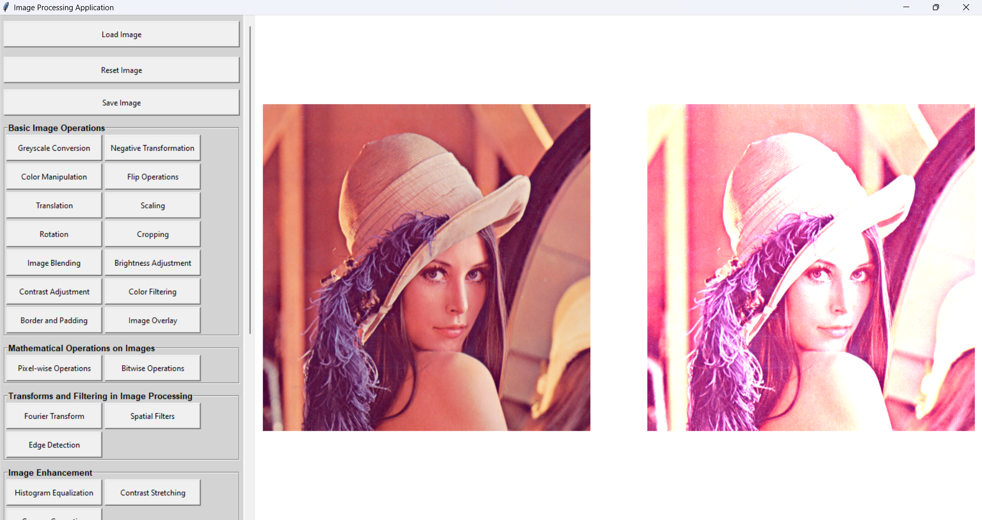

Division

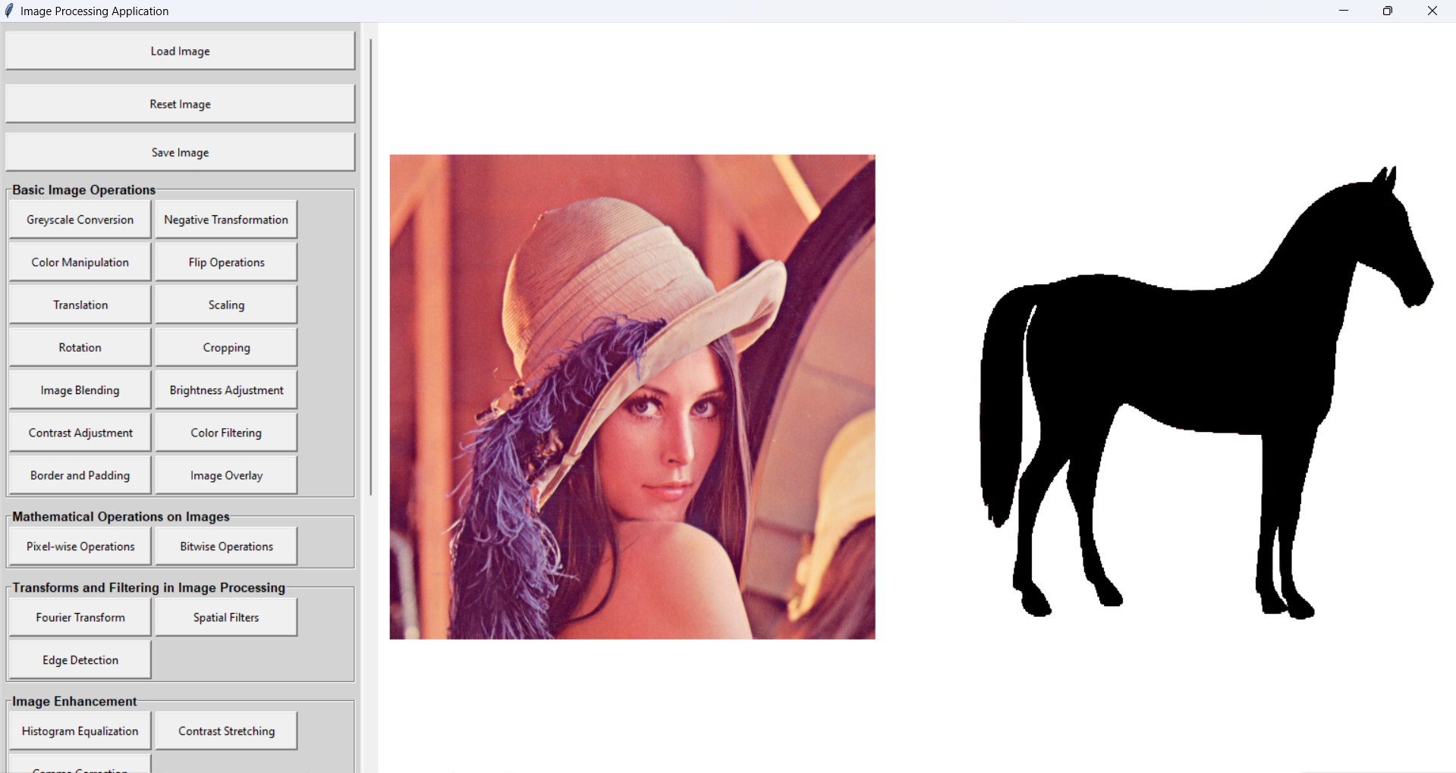

Bitwise operations (add)

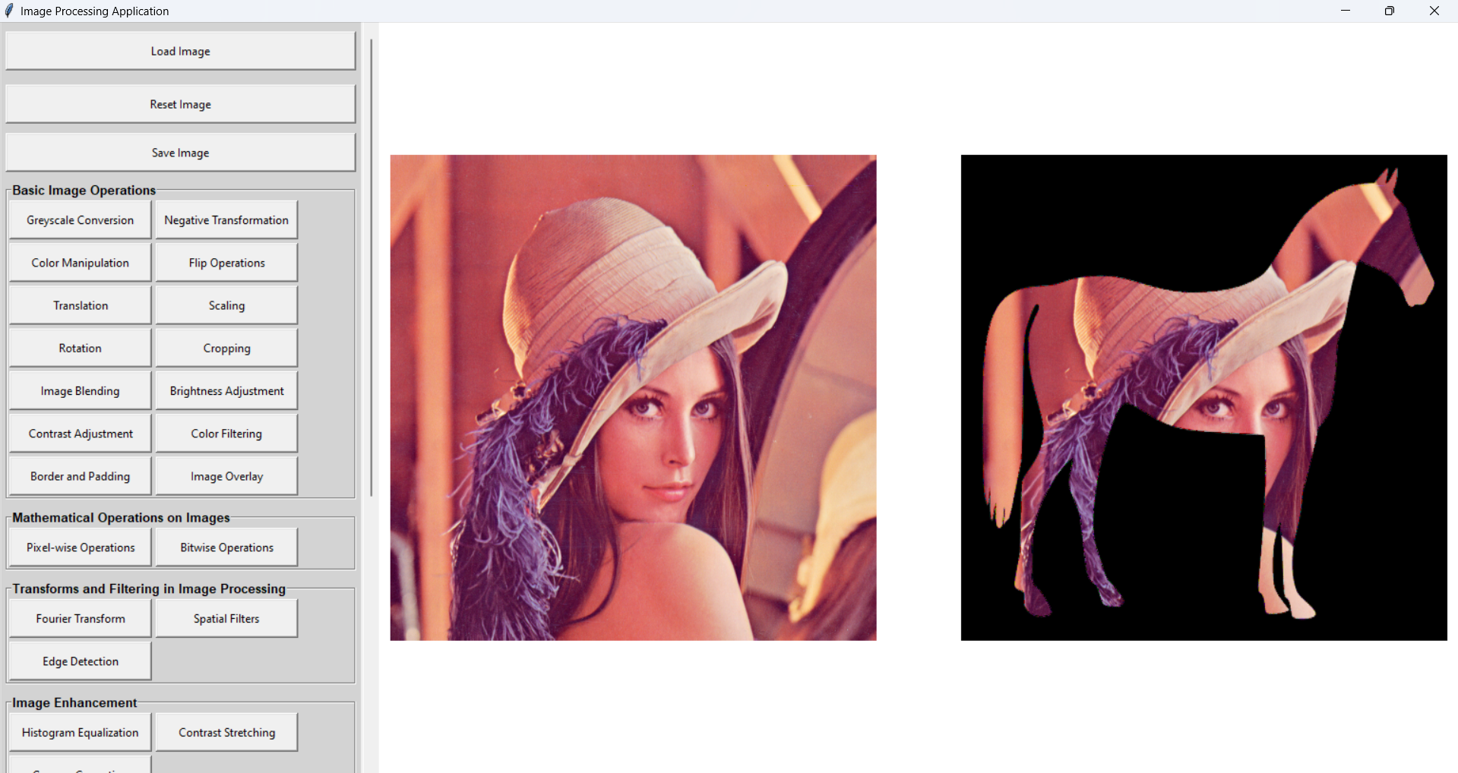

Or

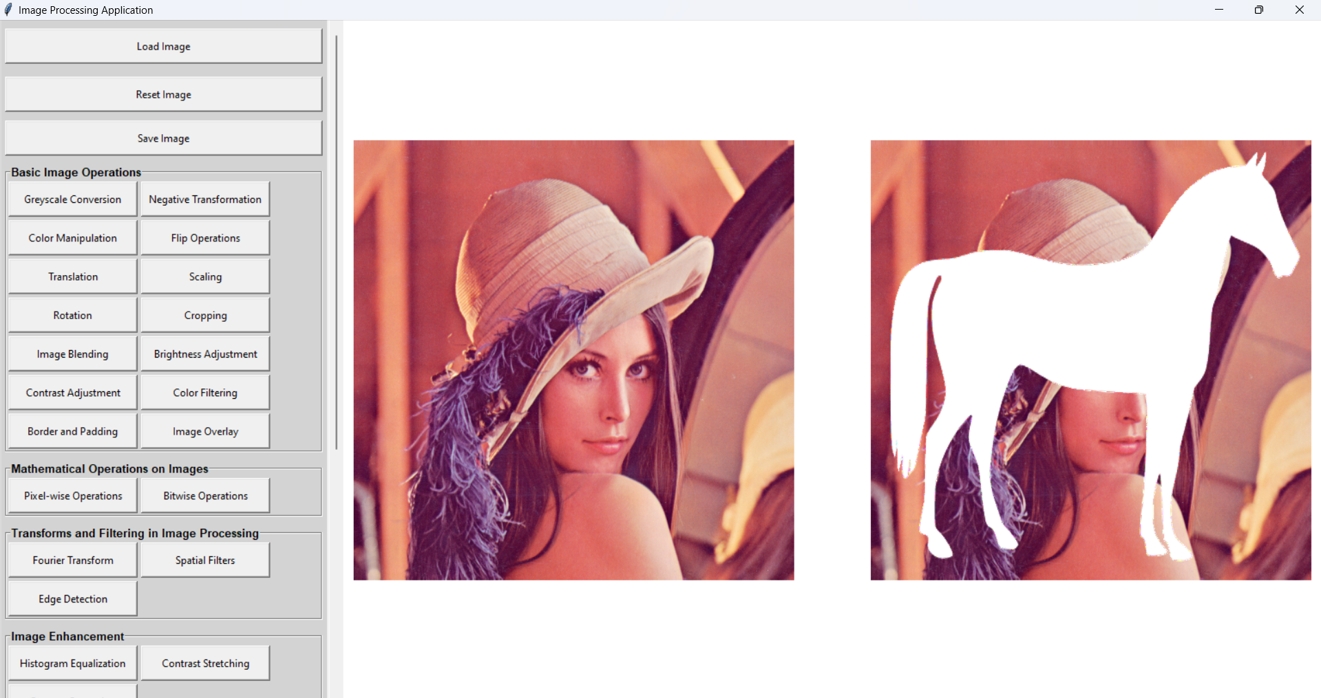

XOR

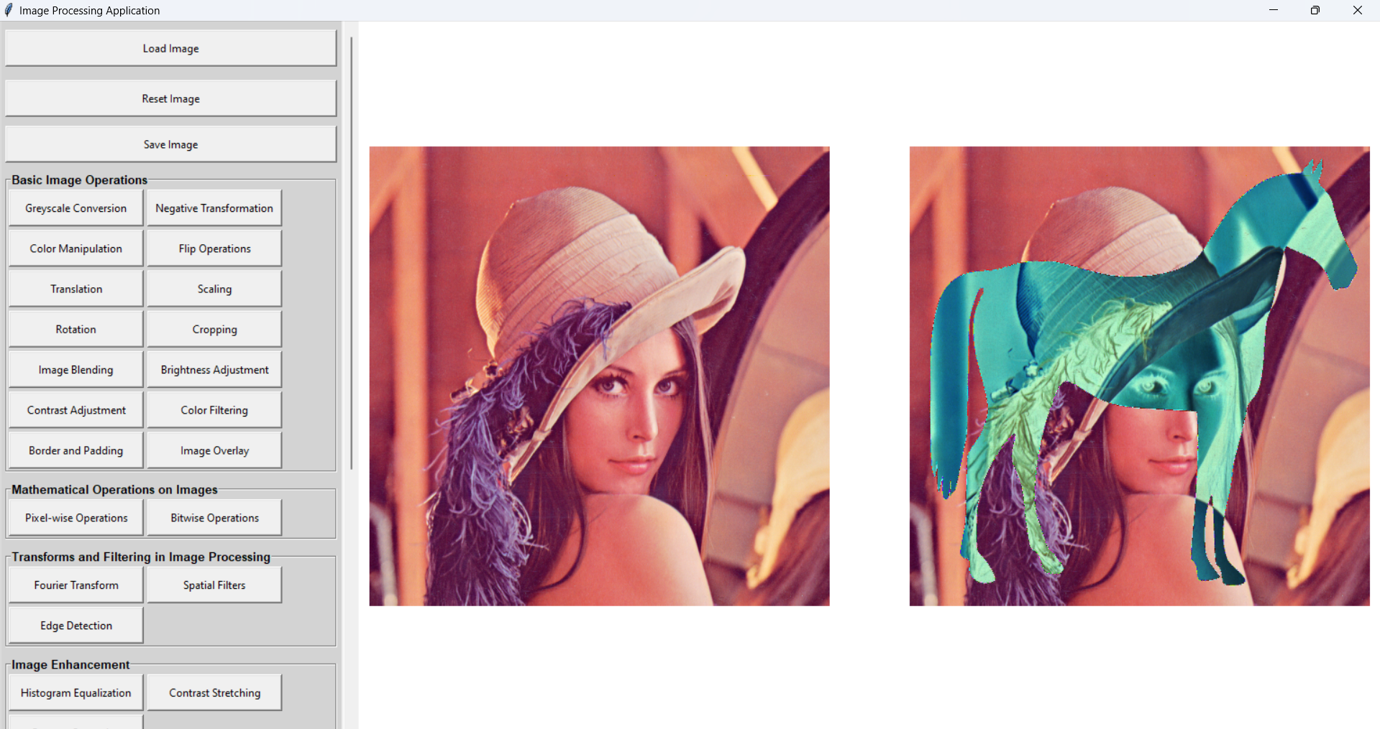

NOT

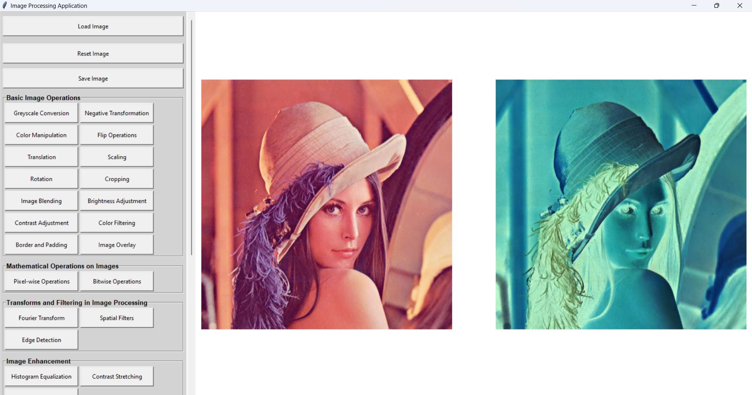

Fourier transform

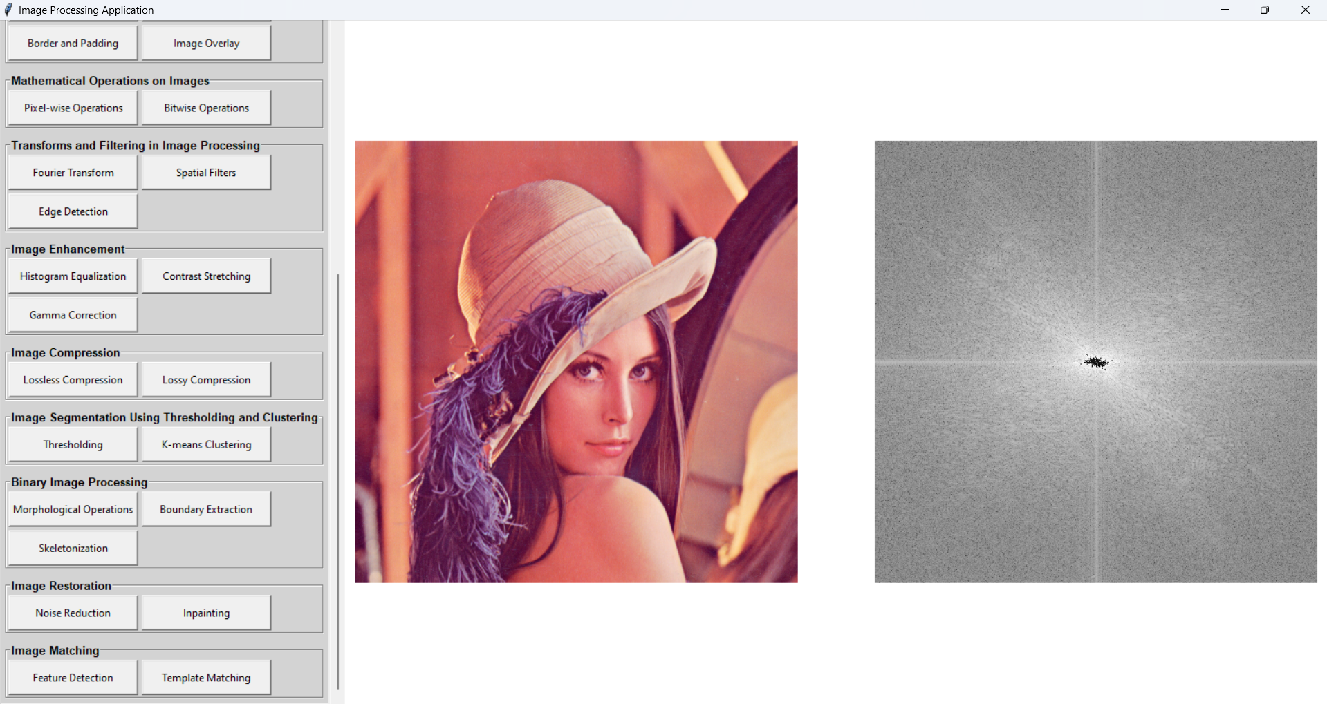

Spatial

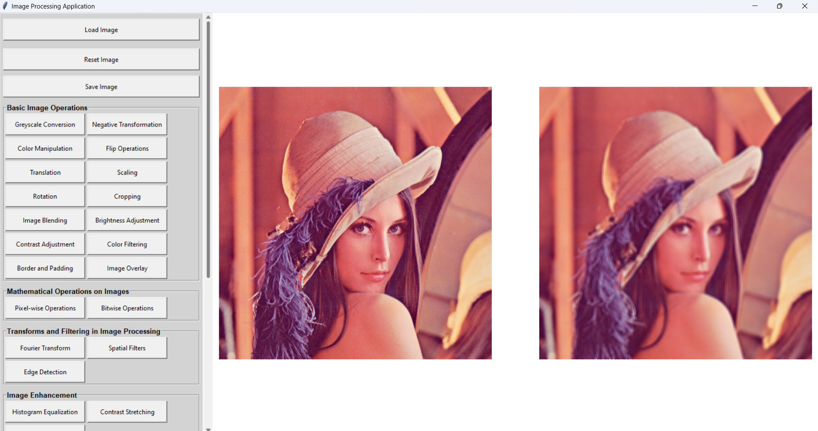

Edge detection

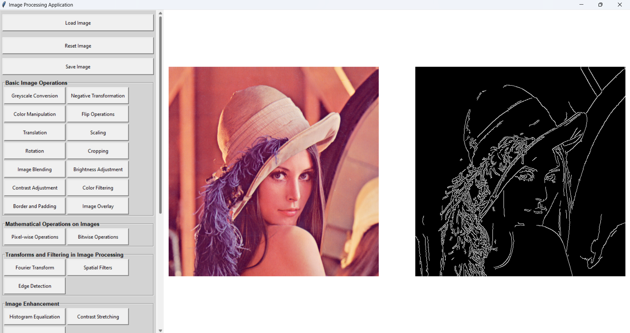

Histogram

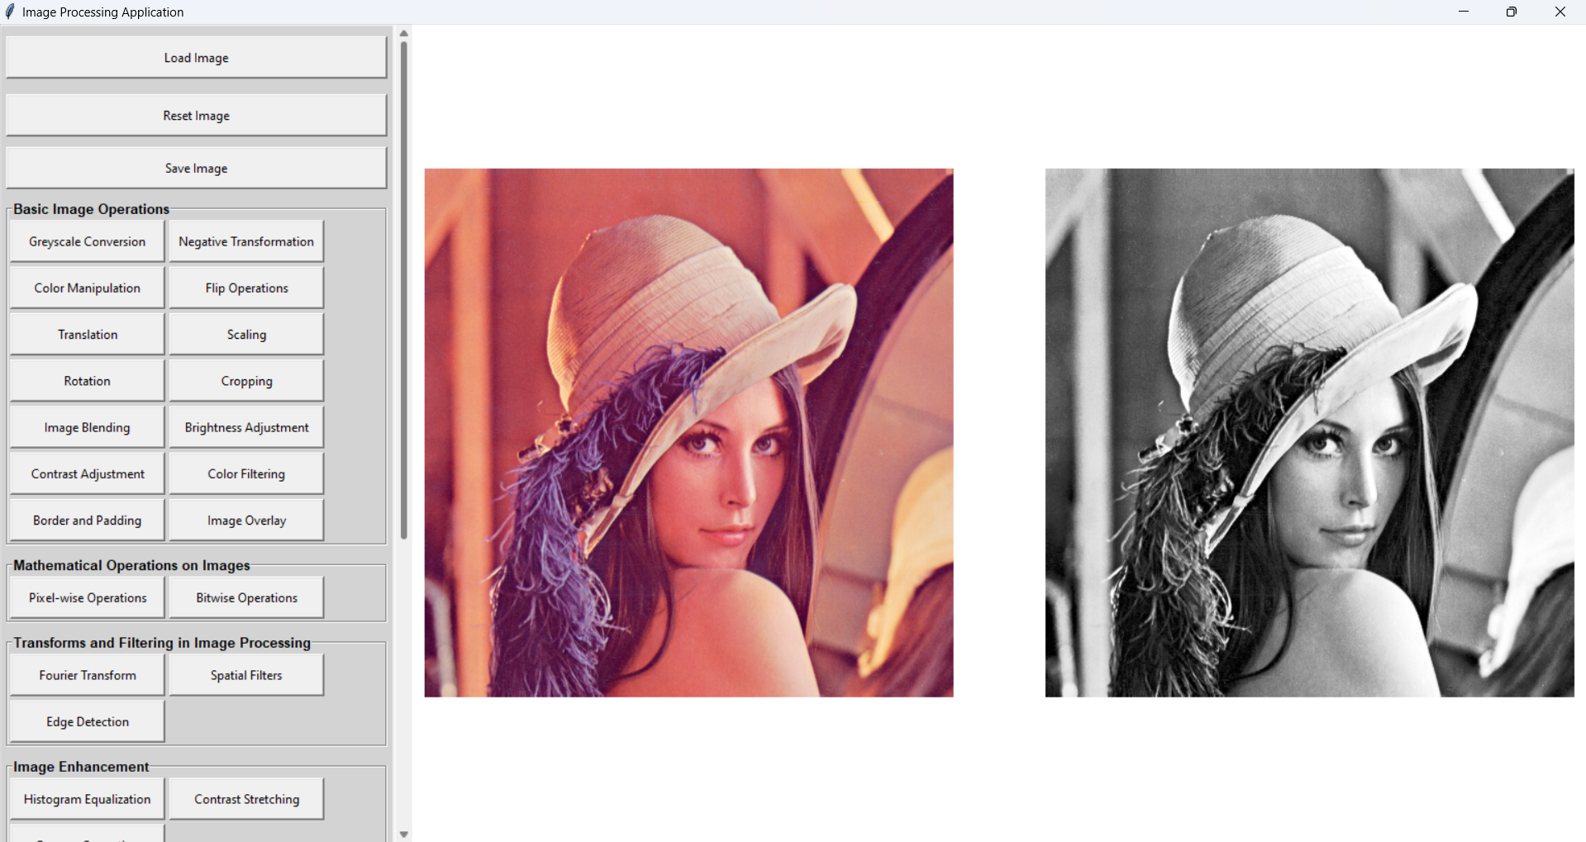

Contrast stretching

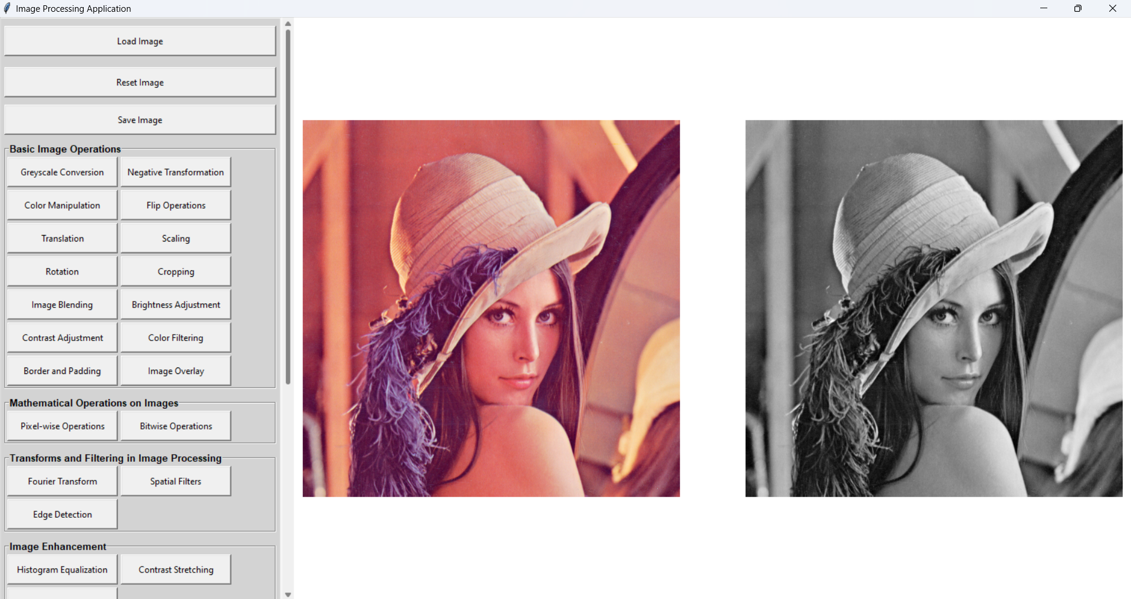

Gamma correction

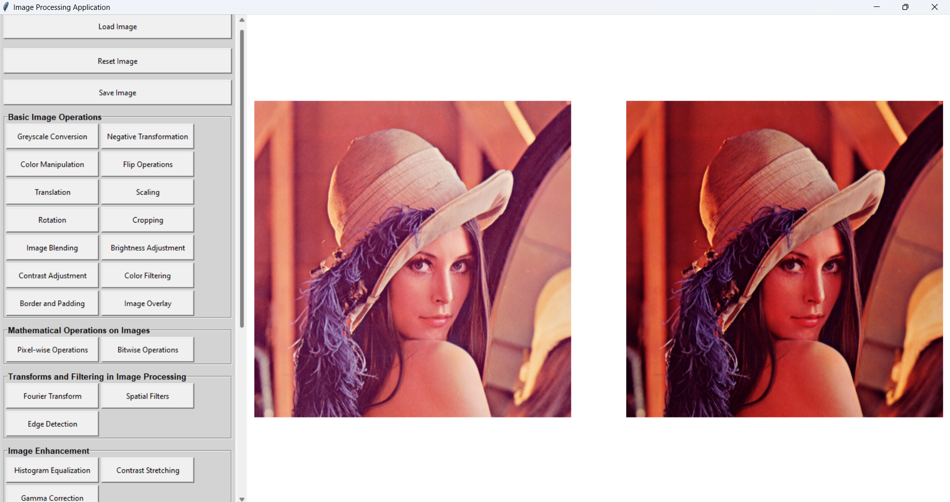

Lossless

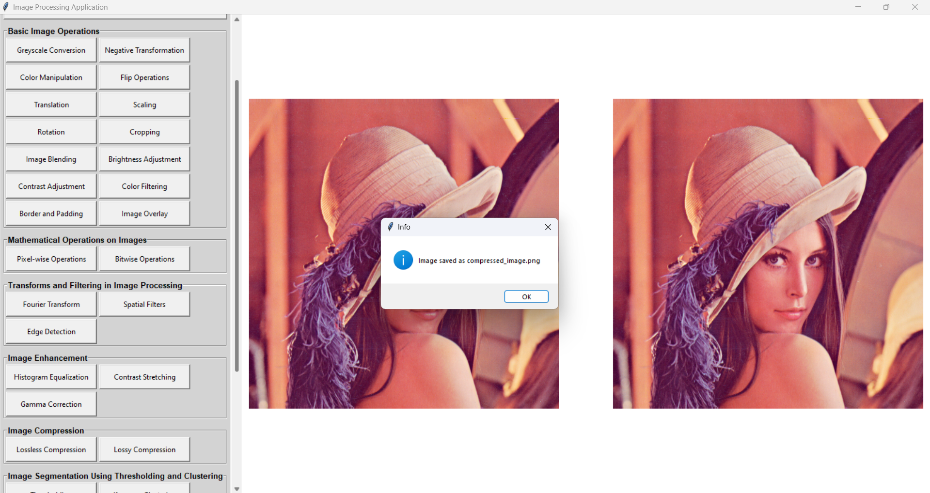

Lossy

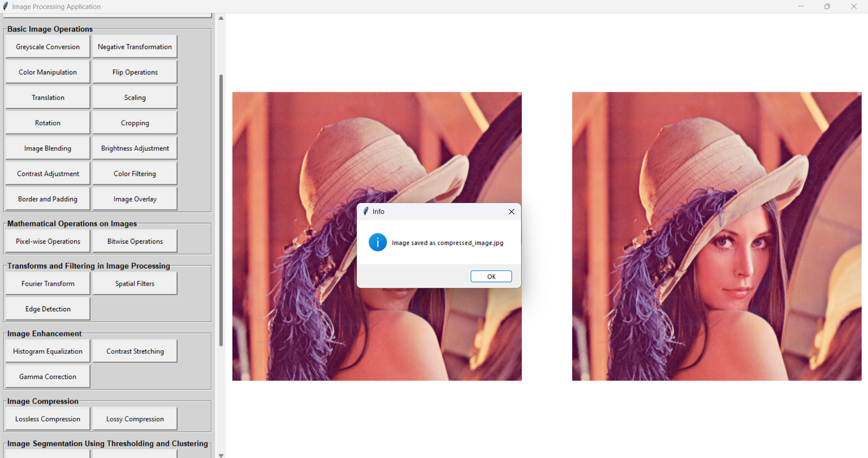



Thresholding

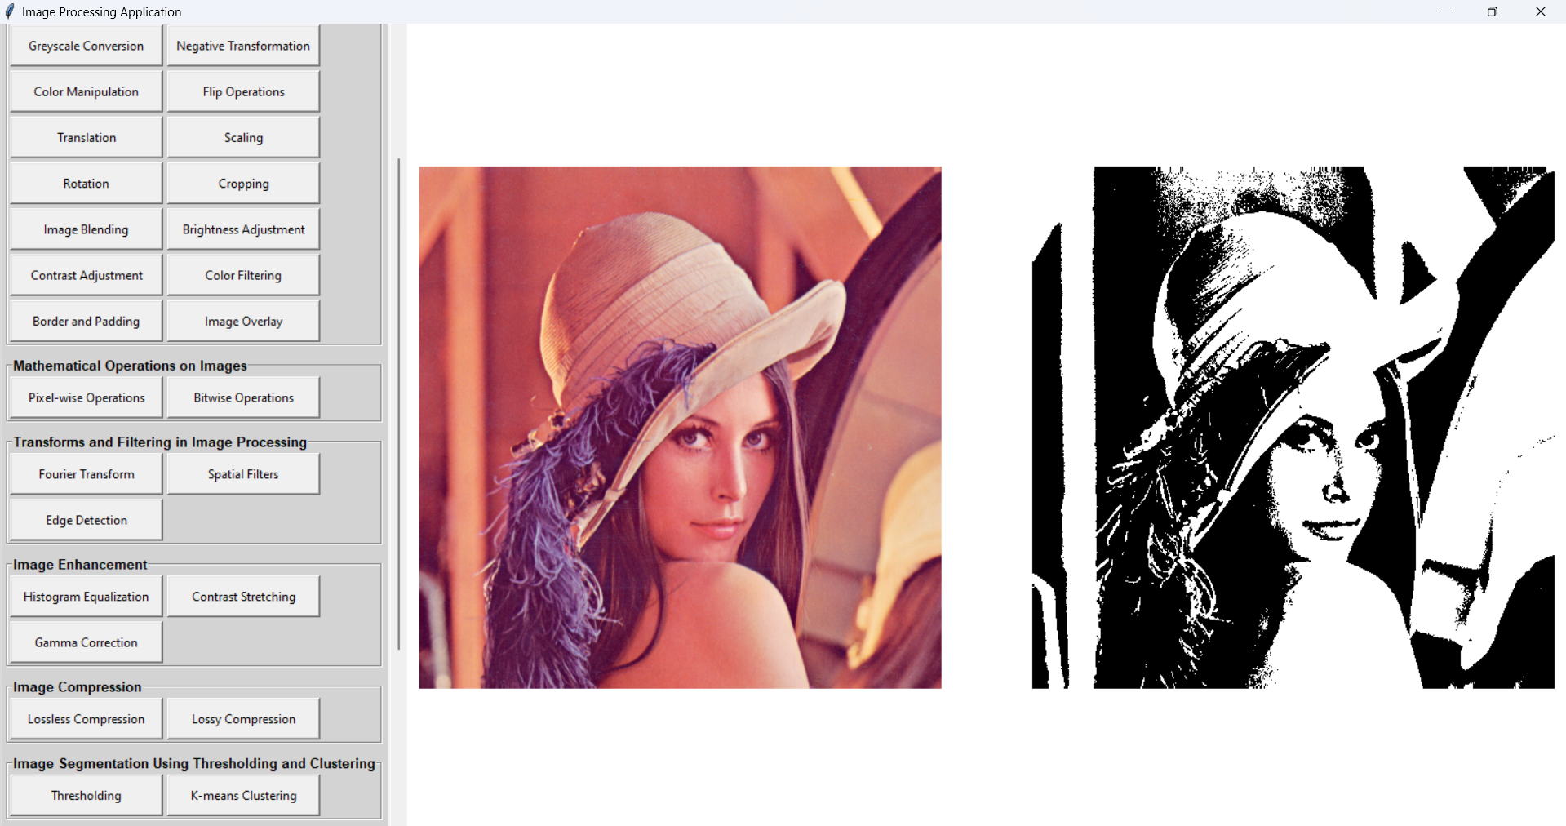

K means

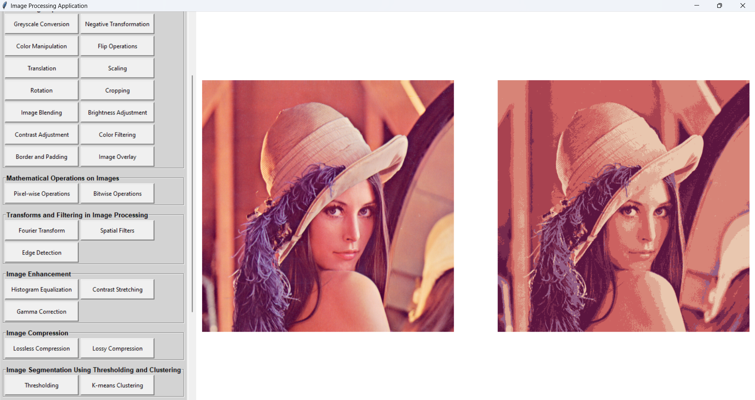

Morphological

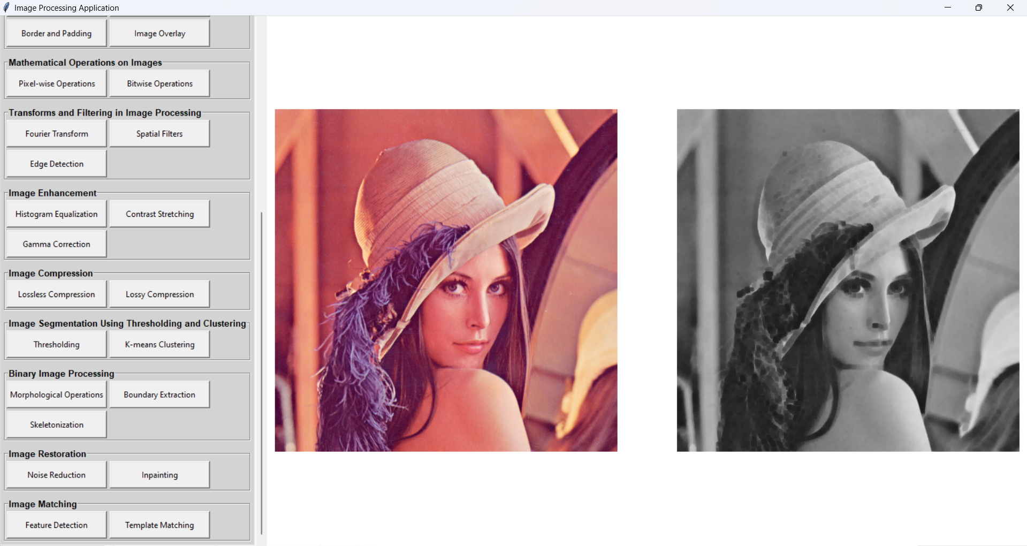

Boundary Extraction

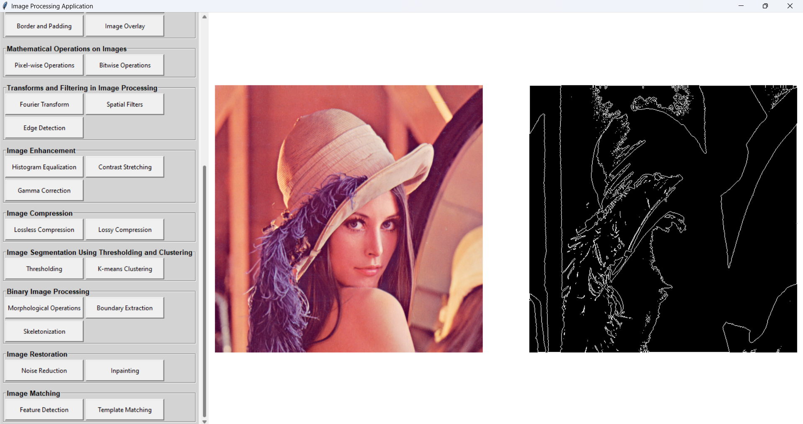

Skeletonization

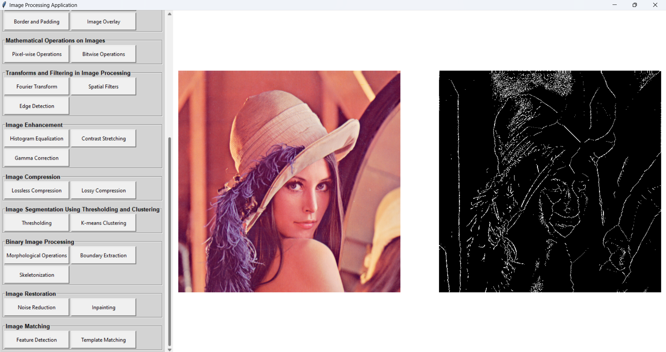

Noise reduction

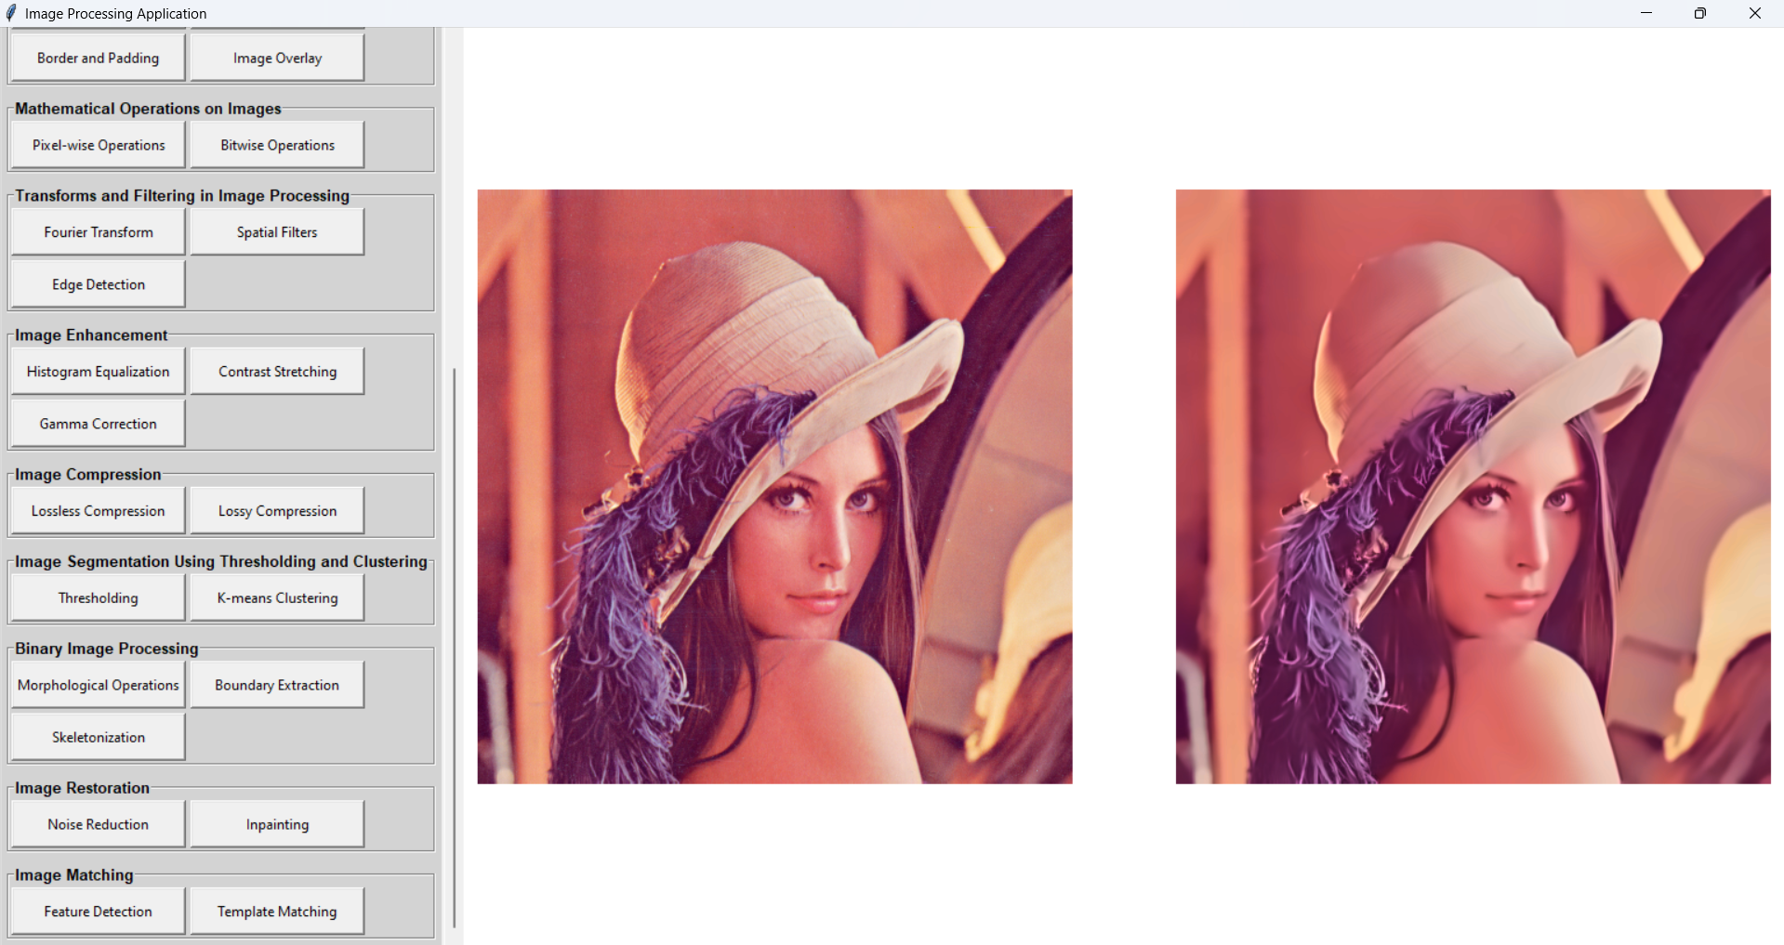

Inpainting

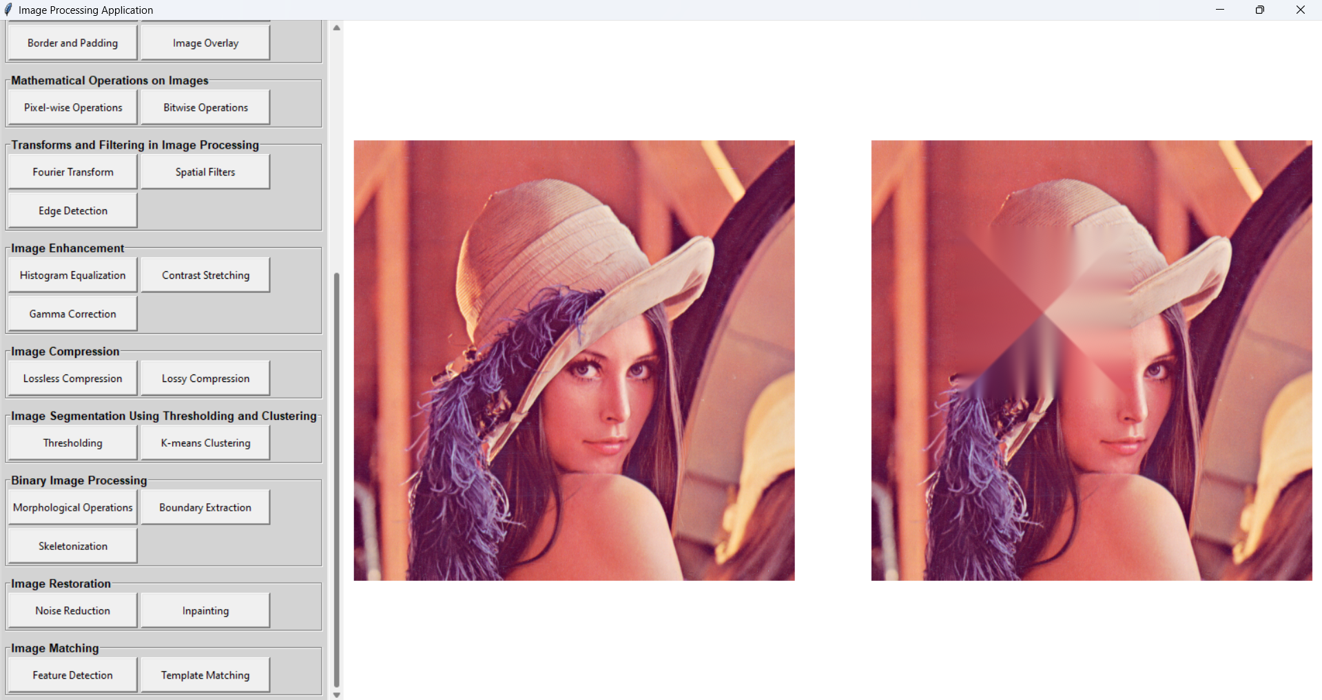

Template Matchin

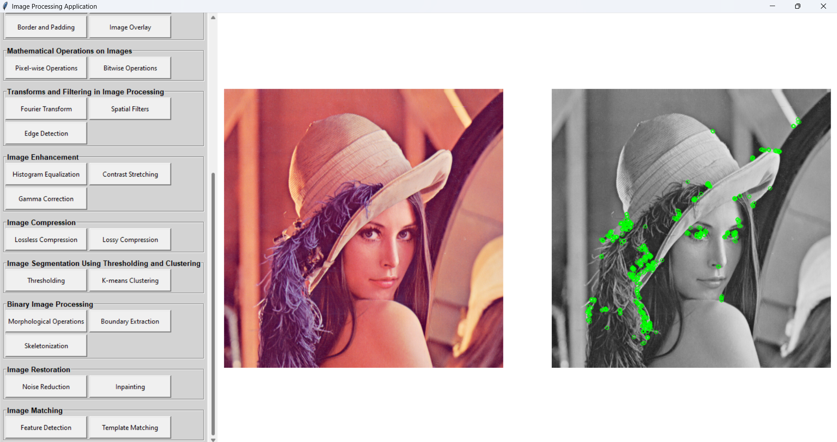

Matching

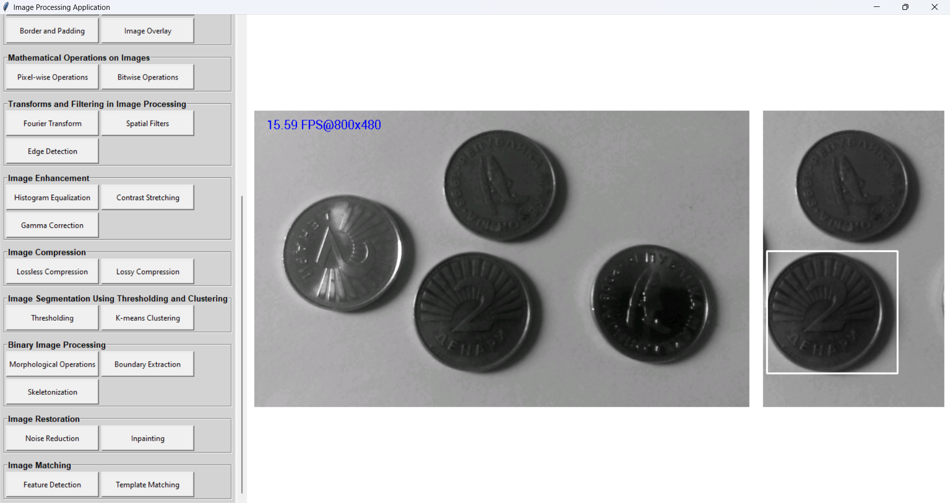

# CHAPTER VI CONCLUSION

## Conclusion

The Image Processing Application developed in this project has successfully demonstrated the implementation of foundational and advanced image processing techniques. By providing a wide array of functionalities—ranging from basic operations such as grayscale conversion and flipping to complex methods like image segmentation, Fourier transforms, and feature matching—this project encapsulates the versatility and importance of image processing in modern applications.

Through the structured approach outlined in the system’s development, students were able to enhance their technical skills, foster collaboration, and gain practical experience with real-world challenges. The intuitive user interface, coupled with comprehensive tools, ensures that the application serves as both an educational resource and a functional tool for image analysis. This project underscores the value of integrating theoretical knowledge with hands-on practice to solve complex problems effectively.

The project goals have been achieved as follows:

* The system provides a user-friendly interface with clearly categorized functionalities.
* Basic and advanced operations are implemented effectively, enabling users to perform a variety of image manipulations.
* The application offers customization and flexibility, catering to diverse user requirements in image processing.
* Team collaboration simulated real-world workflows, enhancing teamwork and problem-solving skills among participants.

Overall, this mini-project serves as a stepping stone for future explorations in the fields of computer vision, machine learning, and artificial intelligence, where image processing plays a pivotal role.

## Results

The outcomes of this project are summarized below, reflecting the functionalities, usability, and effectiveness of the Image Processing Application.

### Functional Features

The application supports the following features:

1. **Basic Image Operations:**
   * Greyscale conversion, negative transformation, color manipulation.
   * Image flipping, rotation, scaling, and cropping.
2. **Mathematical Operations:**
   * Pixel-wise operations and bitwise operations.
3. **Transforms and Filtering:**
   * Fourier transforms, spatial filtering, and edge detection.
4. **Image Enhancement:**
   * Histogram equalization, contrast stretching, and gamma correction.
5. **Image Compression:**
   * Lossless and lossy compression techniques.
6. **Image Segmentation:**
   * Thresholding and k-means clustering.
7. **Binary Image Processing:**
   * Morphological operations, boundary extraction, and skeletonization.
8. **Image Restoration:**
   * Noise reduction and inpainting.
9. **Image Matching:**
   * Feature detection and template matching.

### Usability

* The application is user-friendly and intuitive, with buttons and functionalities logically grouped for ease of access.
* The graphical user interface (GUI) dynamically adapts to user inputs, ensuring smooth operation throughout.
* Navigation between functionalities is seamless, minimizing the learning curve for users.

### Practical Impact

* **Educational Value:** The application provides a hands-on platform for learning image processing techniques.
* **Collaboration:** Students successfully worked as a team, simulating professional workflows and enhancing interpersonal skills.
* **Adaptability:** The modular design of the application allows for future enhancements and integration with other technologies.

### Test Results

Extensive testing verified the accuracy and performance of the application. The functionalities were tested using a variety of sample images to ensure reliability and robustness. The following test cases highlight the results:

|  |  |  |
| --- | --- | --- |
| **Test Case** | **Expected Outcome** | **Result** |
| Load Image | Image is loaded into the workspace | Successful |
| Greyscale Conversion | Image converts to grayscale | Successful |
| Fourier Transform | Frequency domain representation generated | Successful |
| Noise Reduction | Noise is minimized in the image | Successful |
| K-means Clustering | Image is segmented into clusters | Successful |
| Template Matching | Template found in the image | Successful |

The results indicate that the application performs as intended, meeting the objectives and providing a robust platform for image processing.

## Future Work

While the project achieved its objectives, there is potential for further development, including:

* Integration of deep learning techniques for advanced image recognition.
* Enhancing the user interface for better accessibility and responsiveness.
* Adding support for batch processing to handle multiple images simultaneously.
* Exploring cross-platform compatibility for broader usage.

This project lays the foundation for future advancements and encourages continued exploration in the dynamic field of image processing.